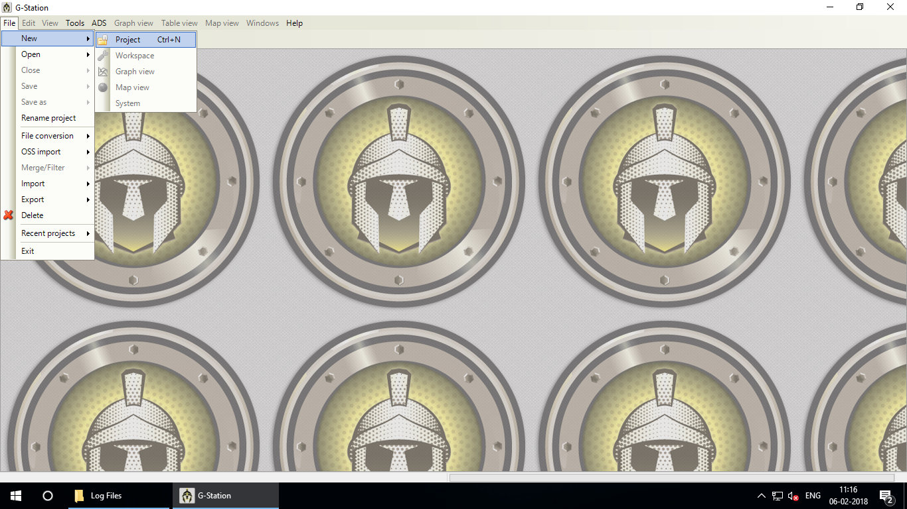

Open gladiator – File – New - Project

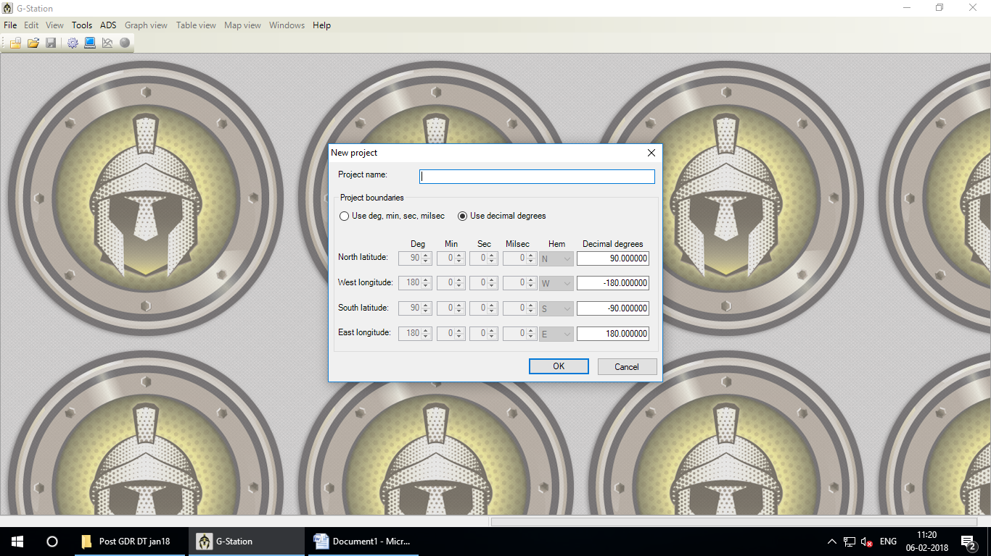

**Project Name**: give file name – OK

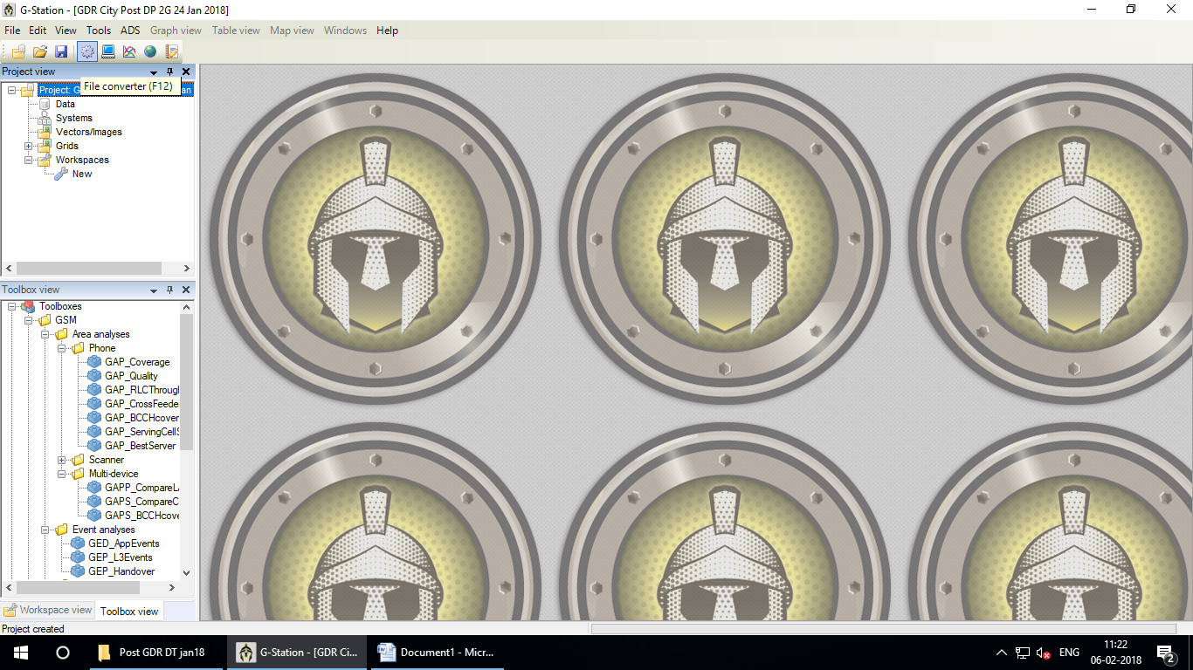

Click on **File Converter**

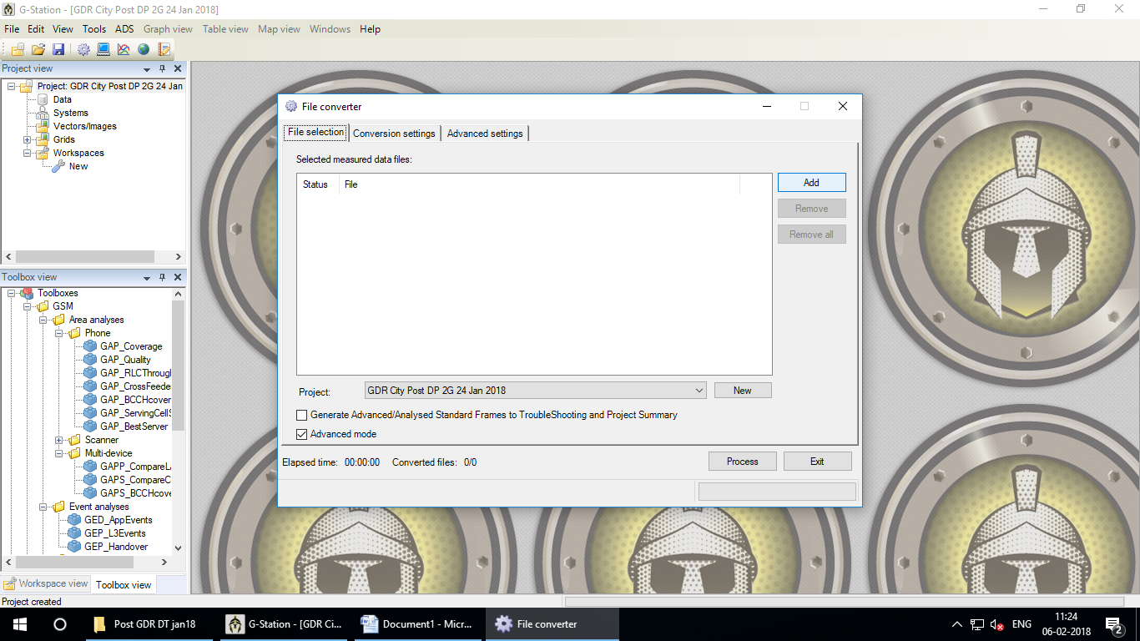

Click on **Add**

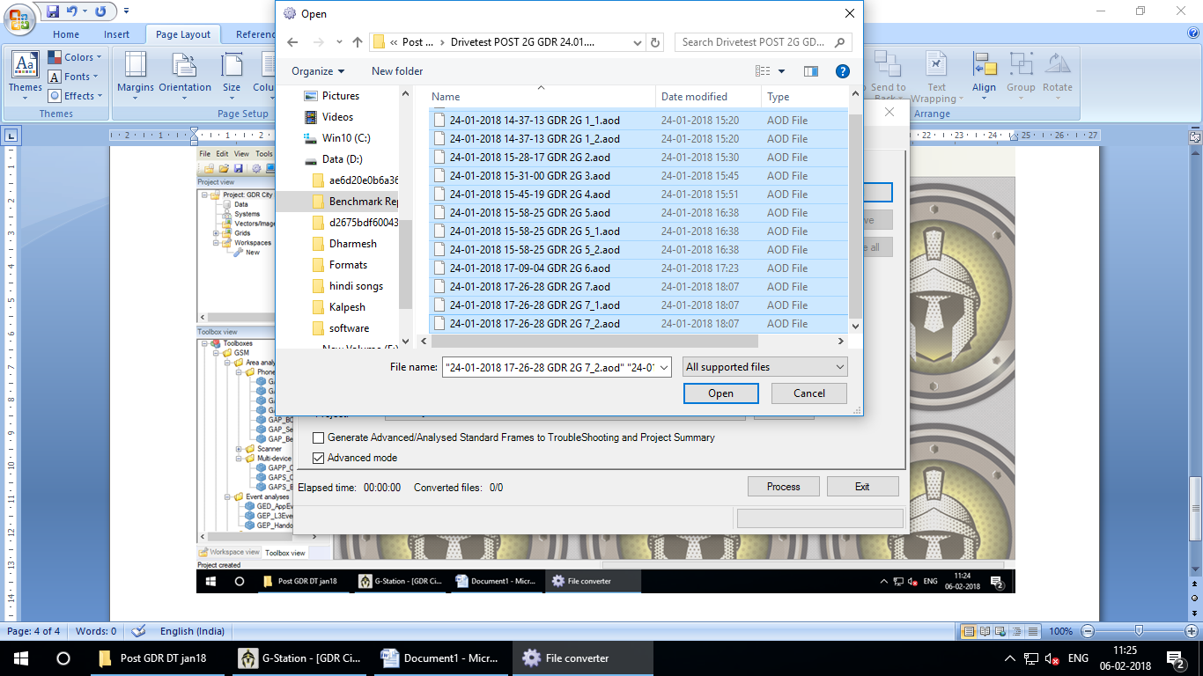

Select all log file from your source

Select all log file from your source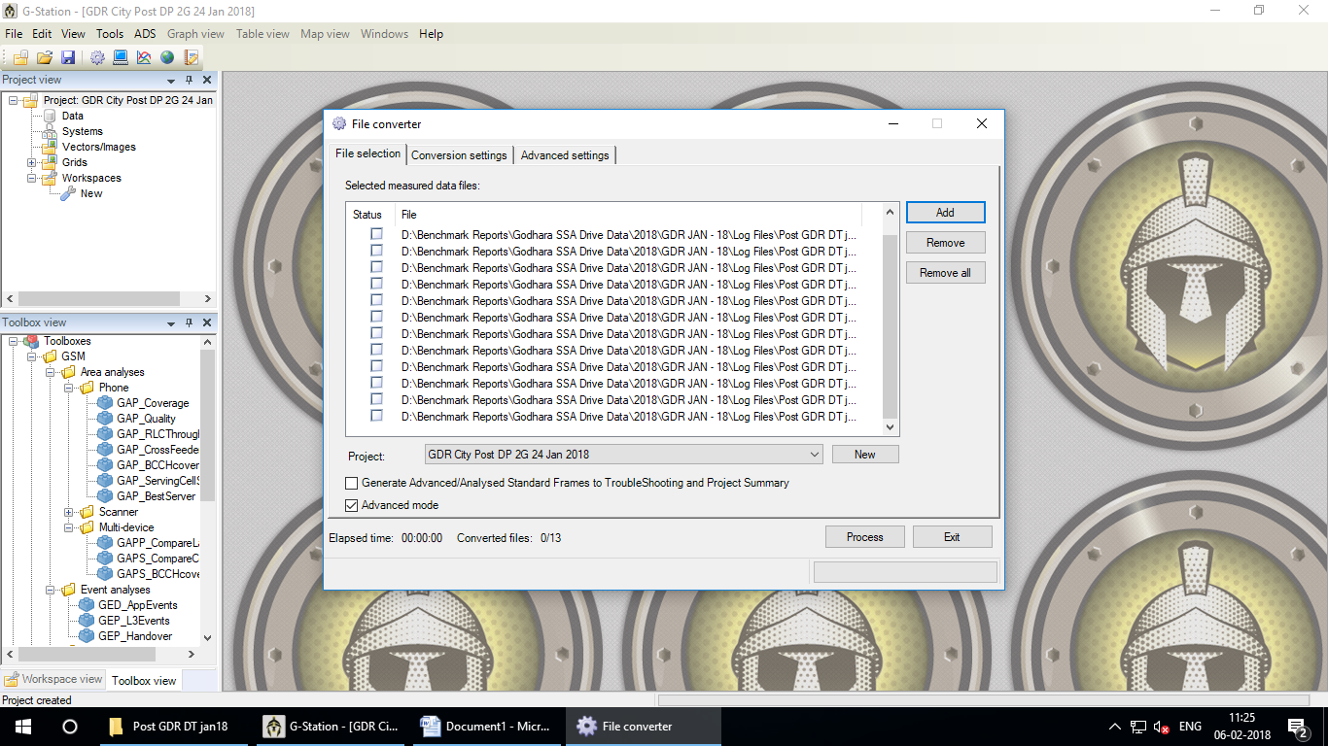

Click on **Process**

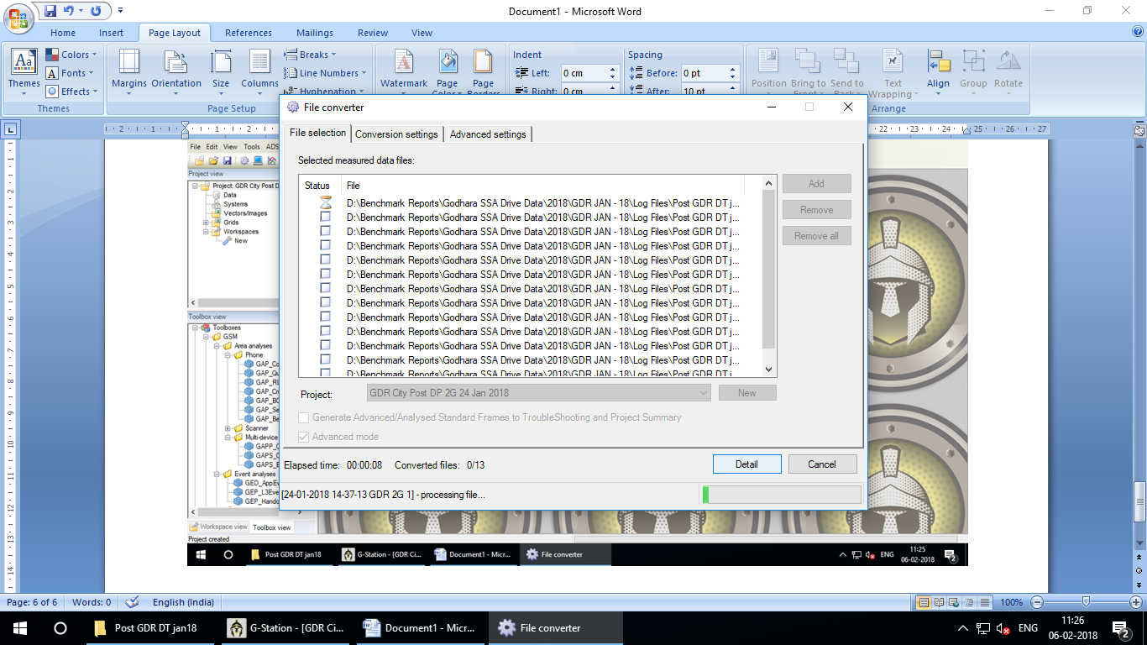

Please wait 5 to 10 minutes. (it takes some time)

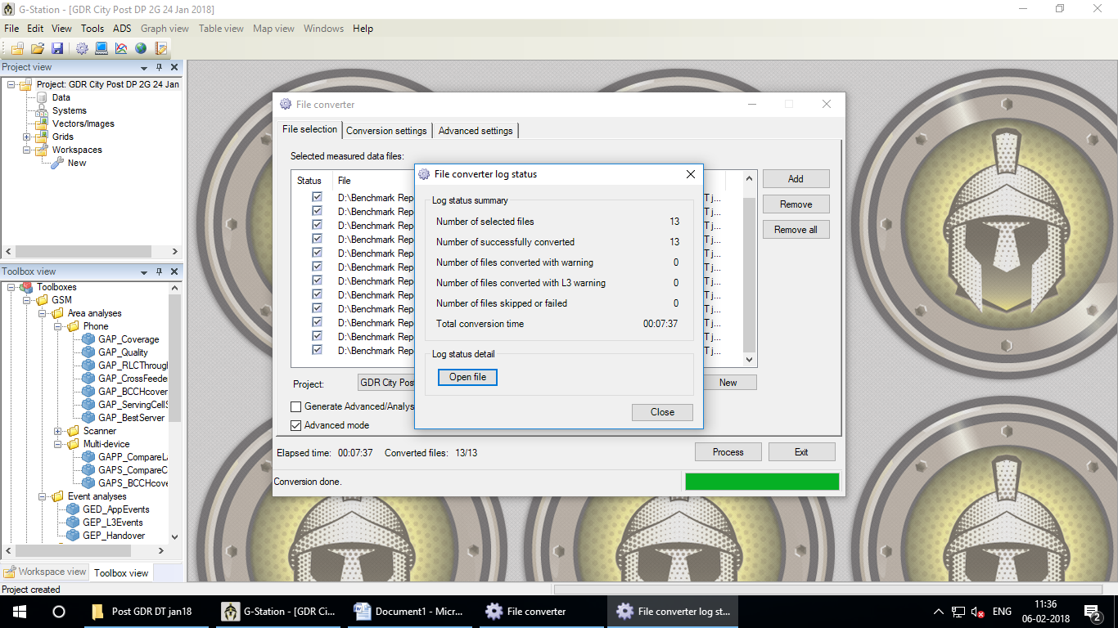

All File Converted successfully - **Close**

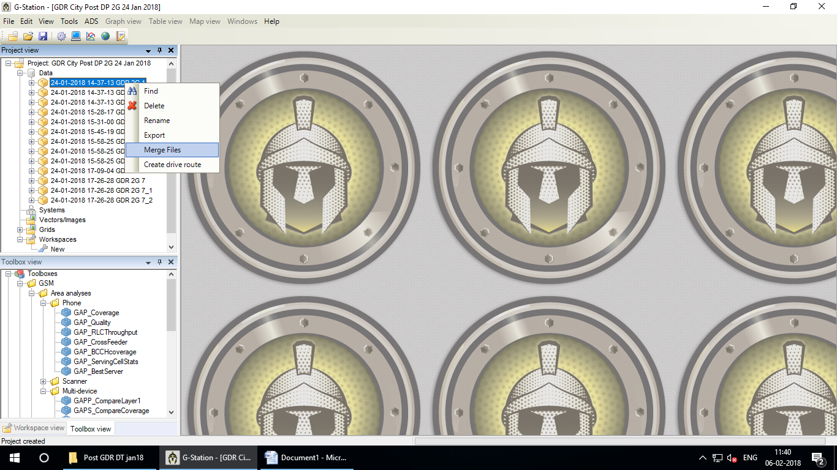

Select any file – Right Click - **Merge Files**

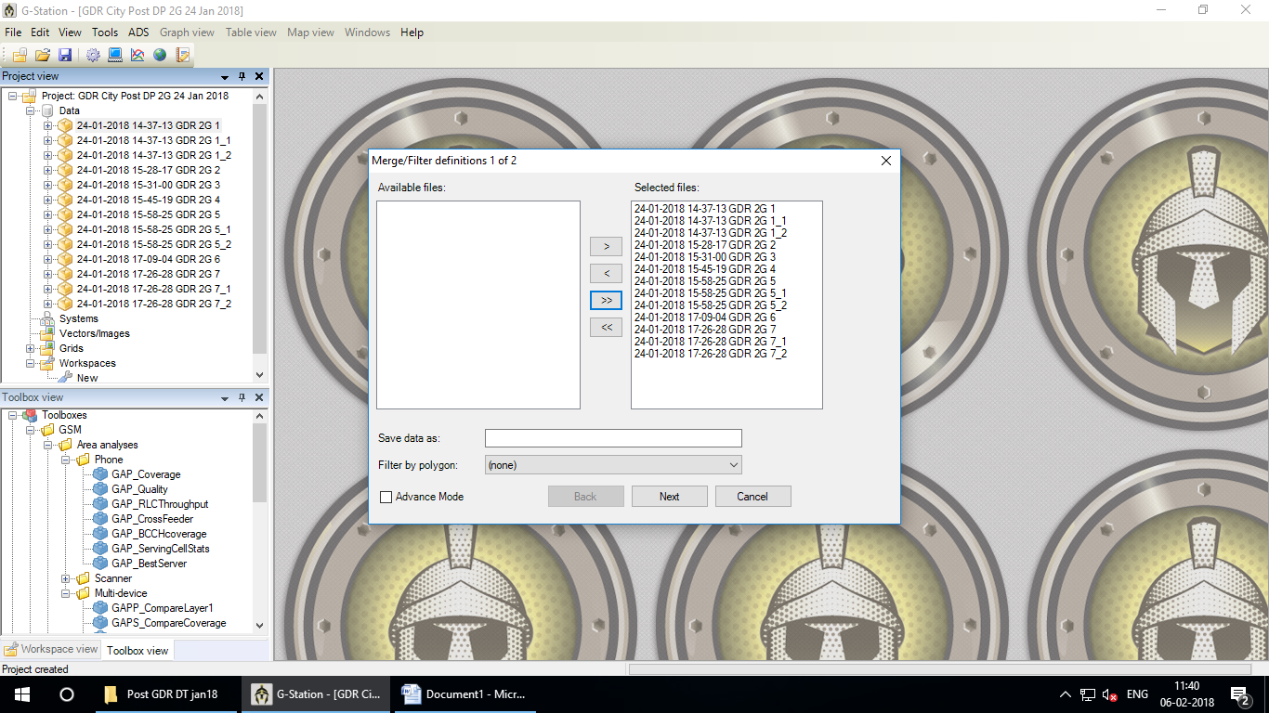

Select “ >>” to Select all files on Right Side

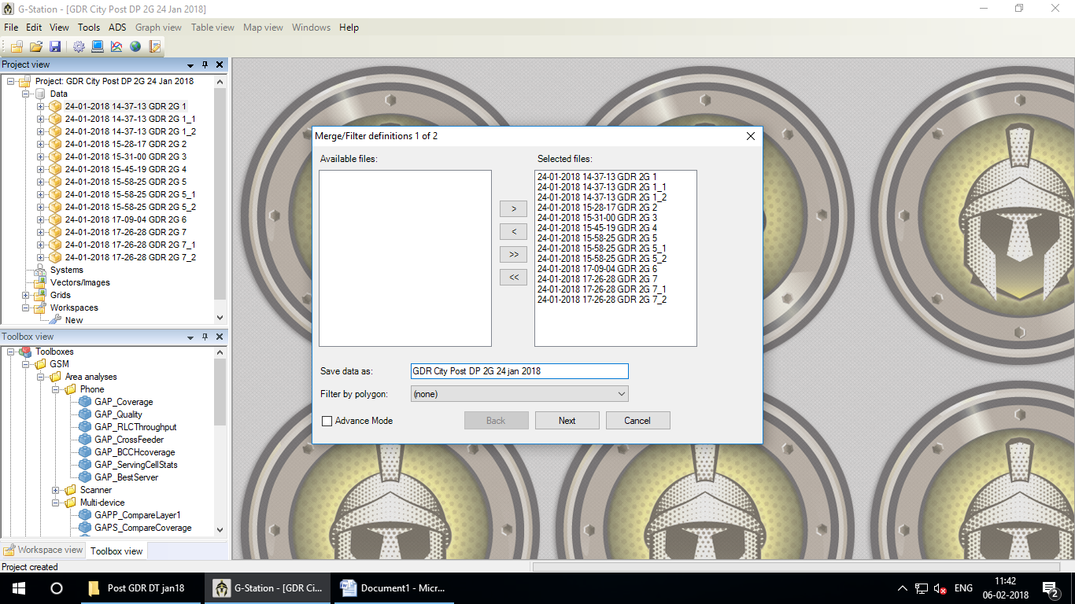

**Save data as**: Give name than Click on **Next**

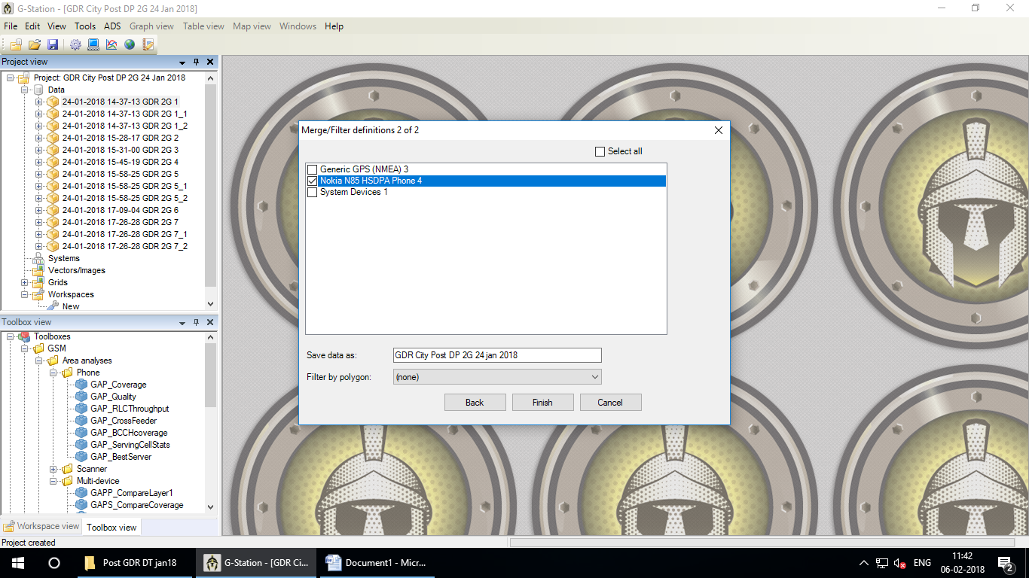

Select device which used in drive test than Click on Finish

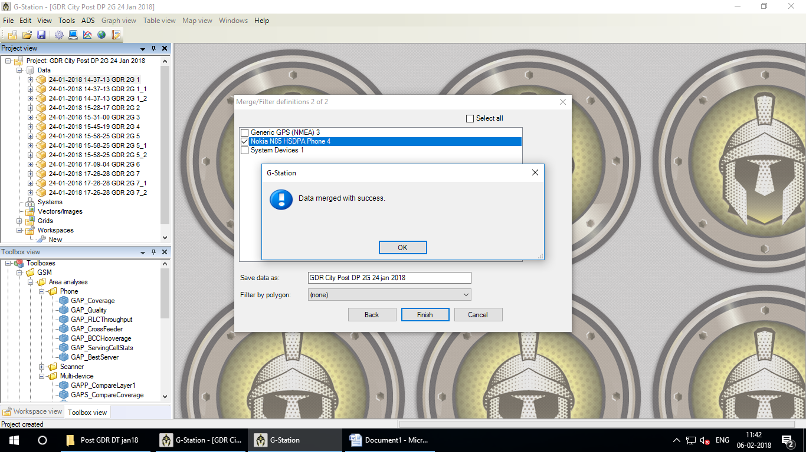

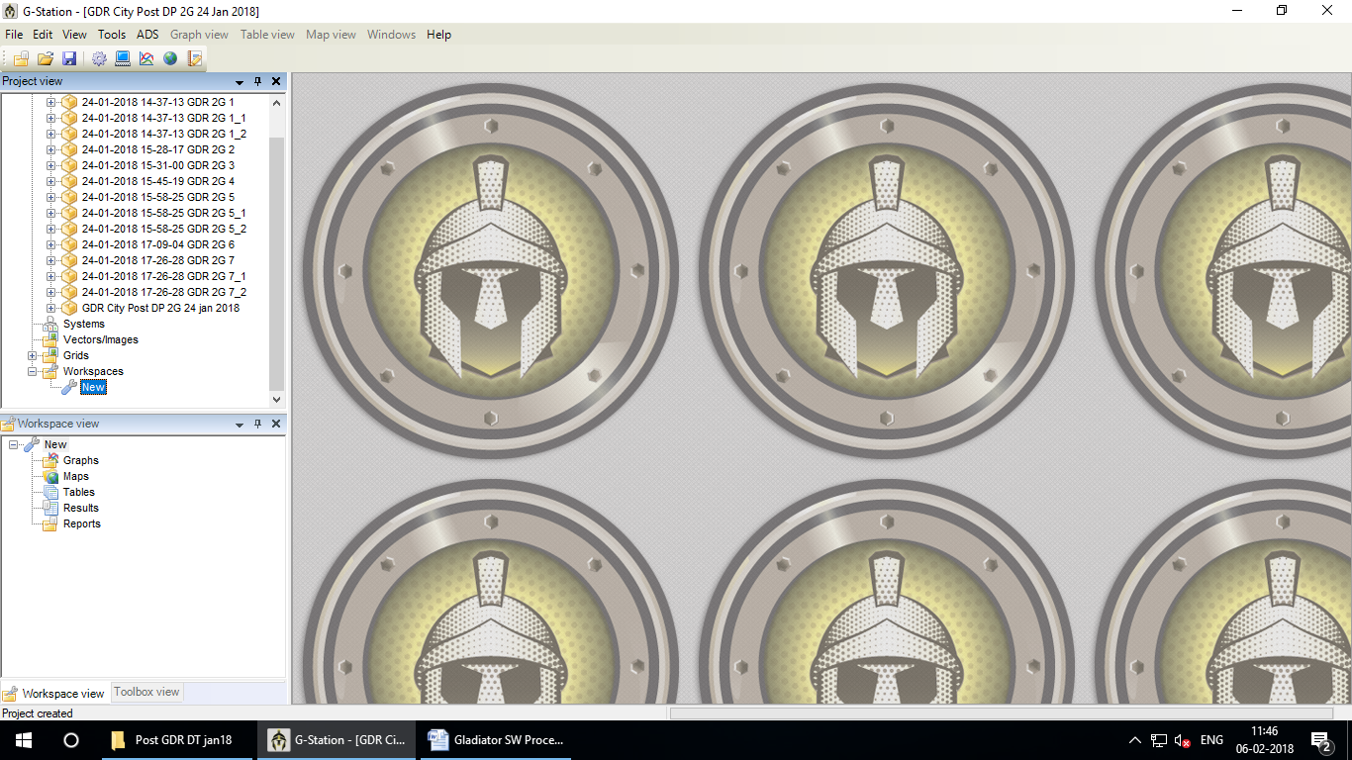

Click on Workspaces –Select **New** than drag and drop to **Workspaces view**

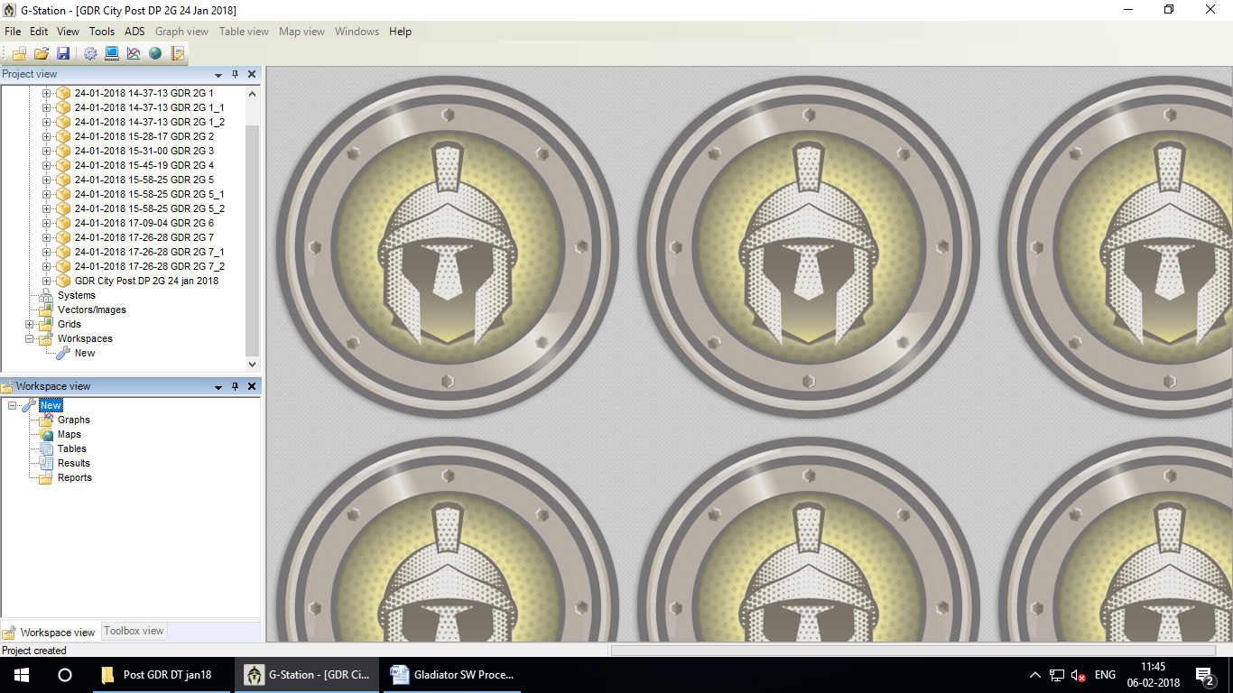

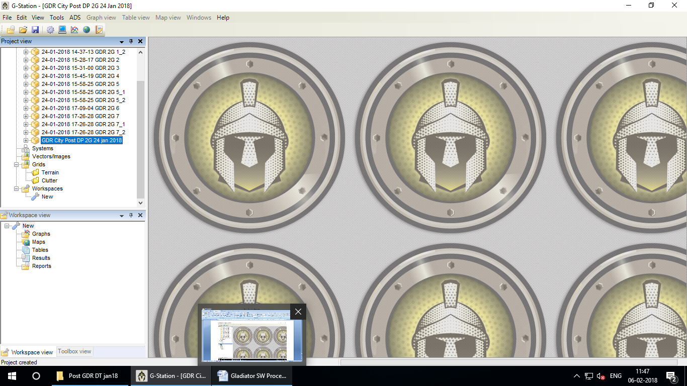

Select your merge file than drag and drop to **Workspaces view**

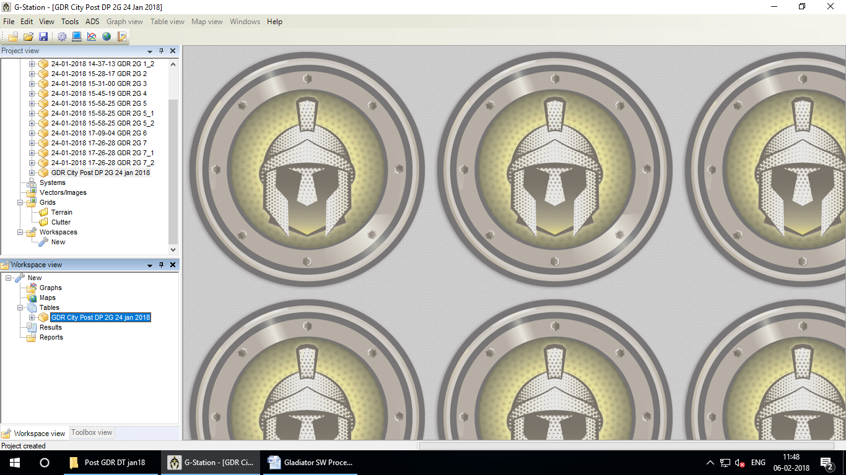

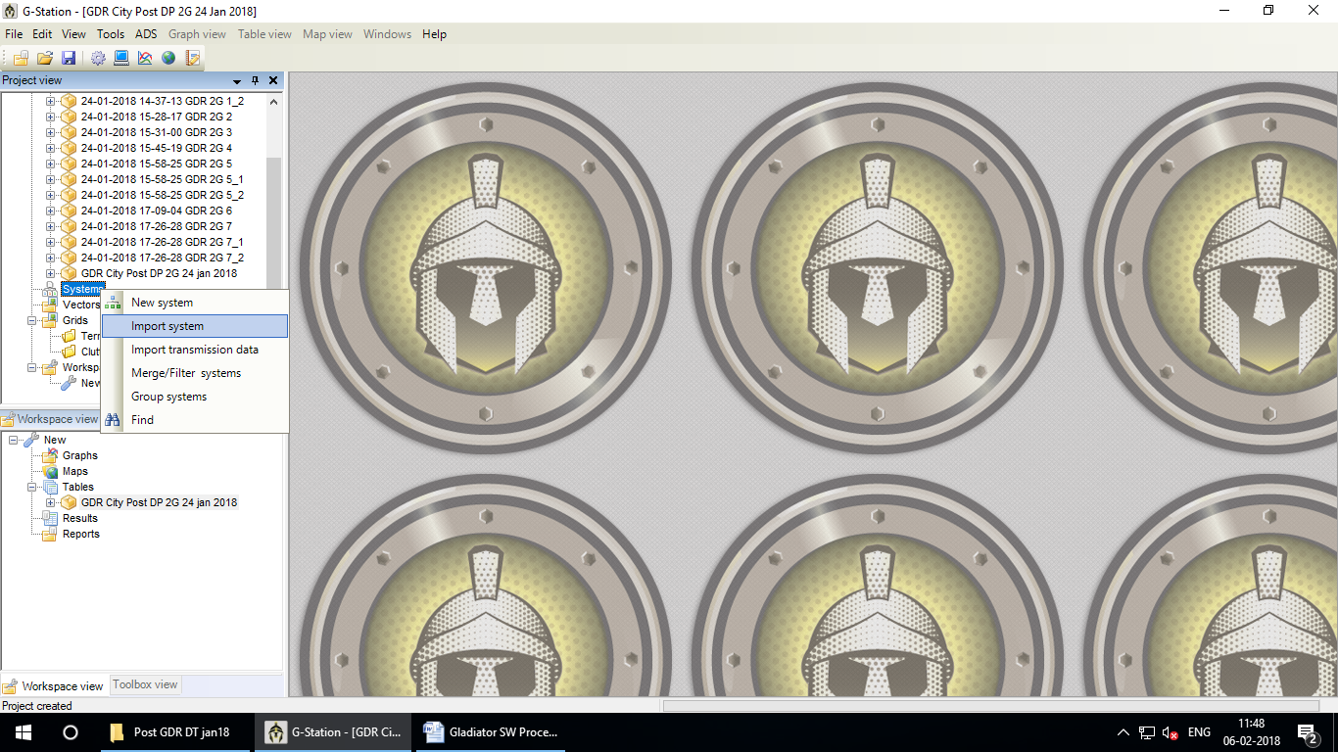

Select **System** - Right Click- Select **Import system**

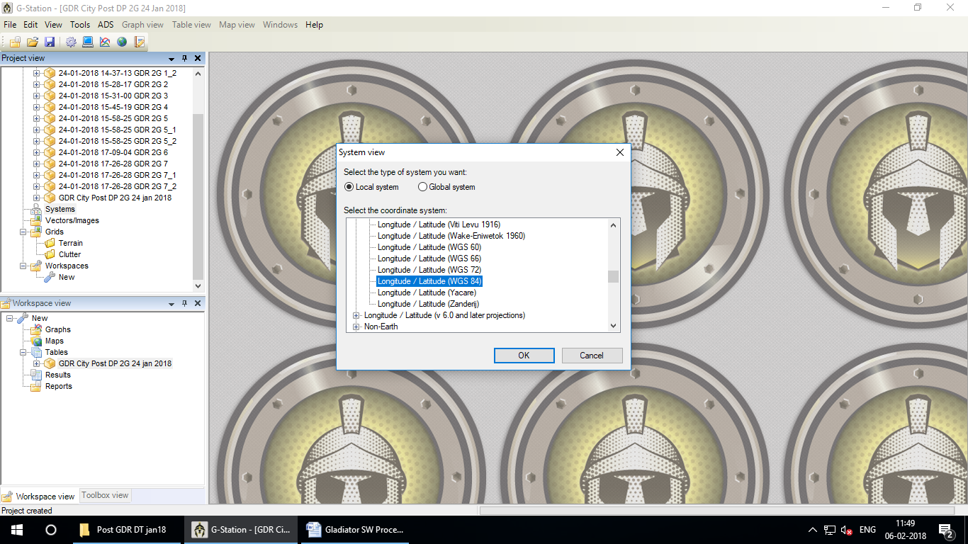

Select **Longitude/Latitude (WGS 84)** - OK

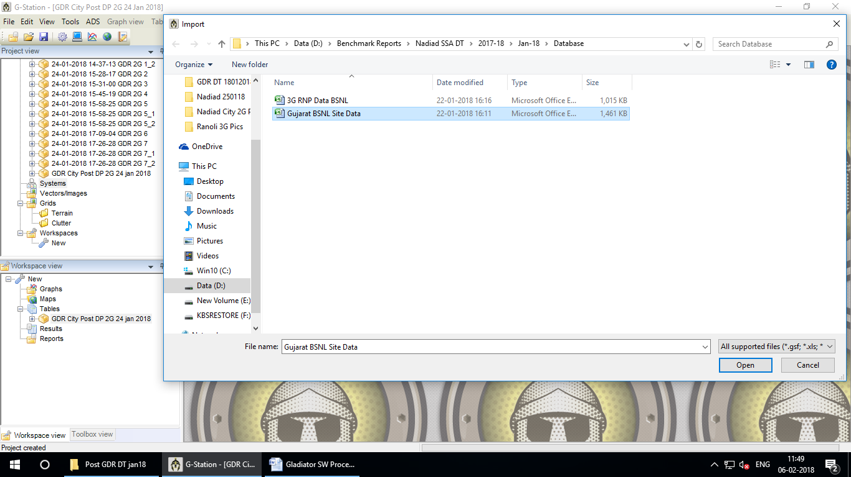

Select your Site Date from your source than **Open**.

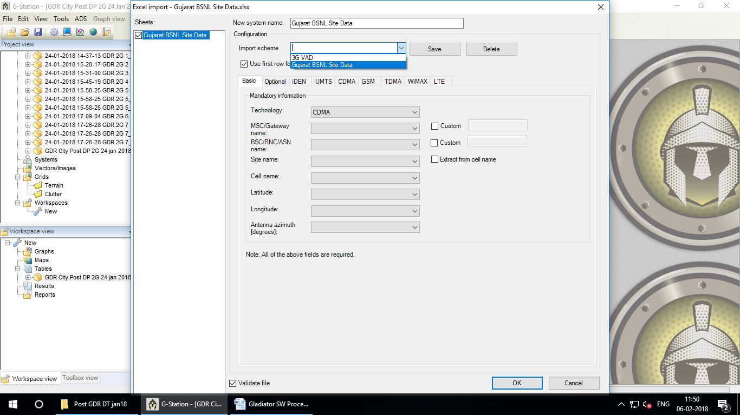

Click on Import scheme and select your data base or make Import scheme with your choice and **Save**

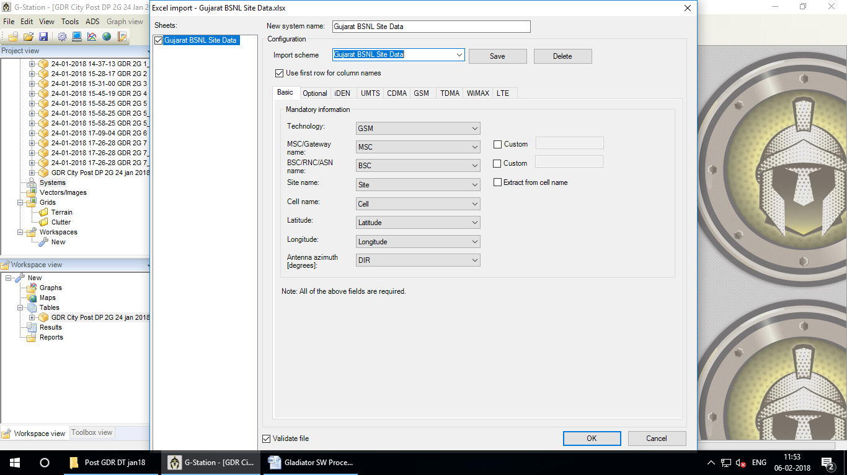

Click on **OK**

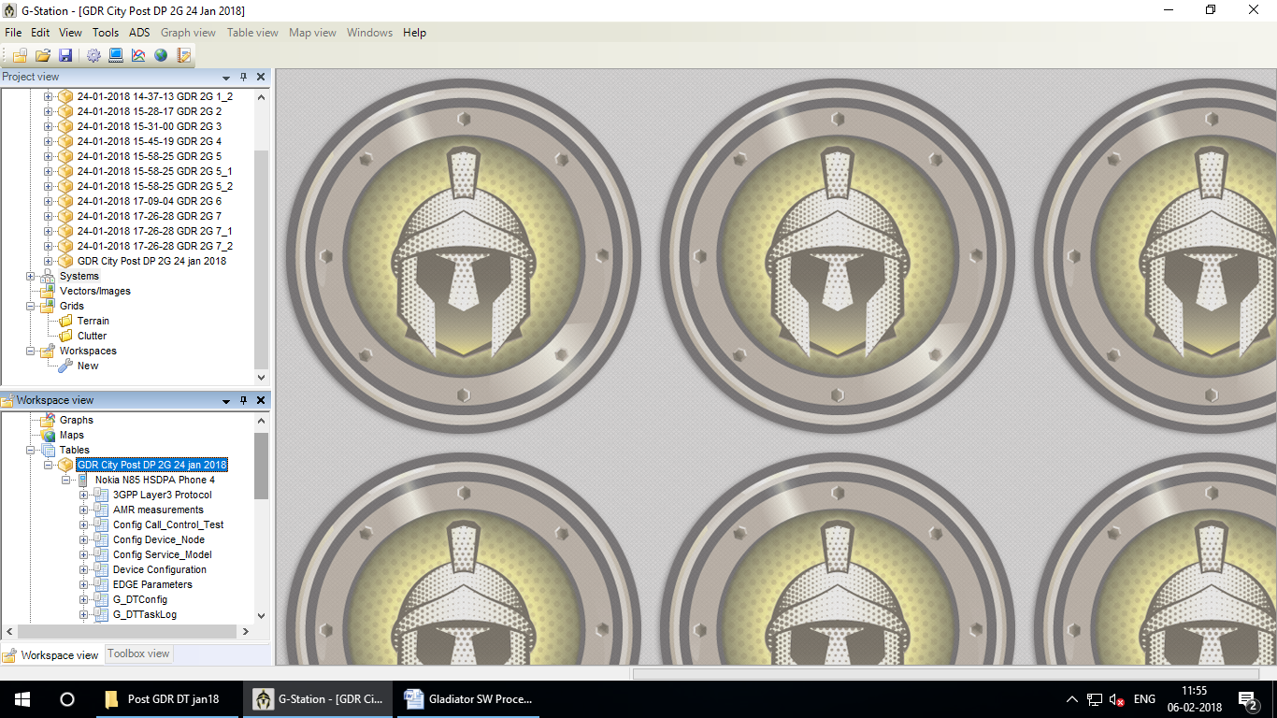

Expand **Tables** – Expand file Name **(GDR City Post DP 2G 24 Jan 2018)**

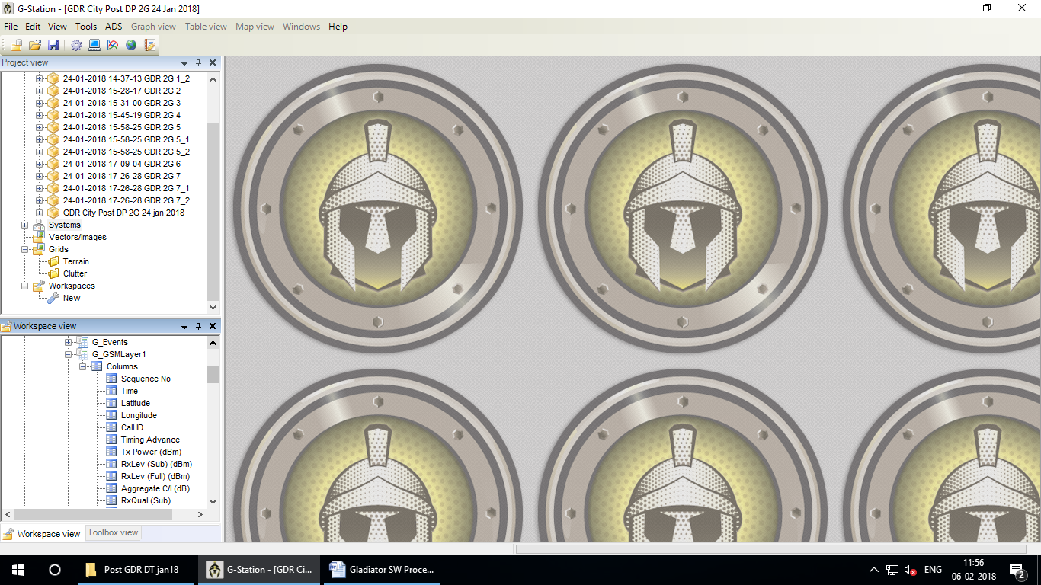

Expand **G_GSMLayer1 – Columns**

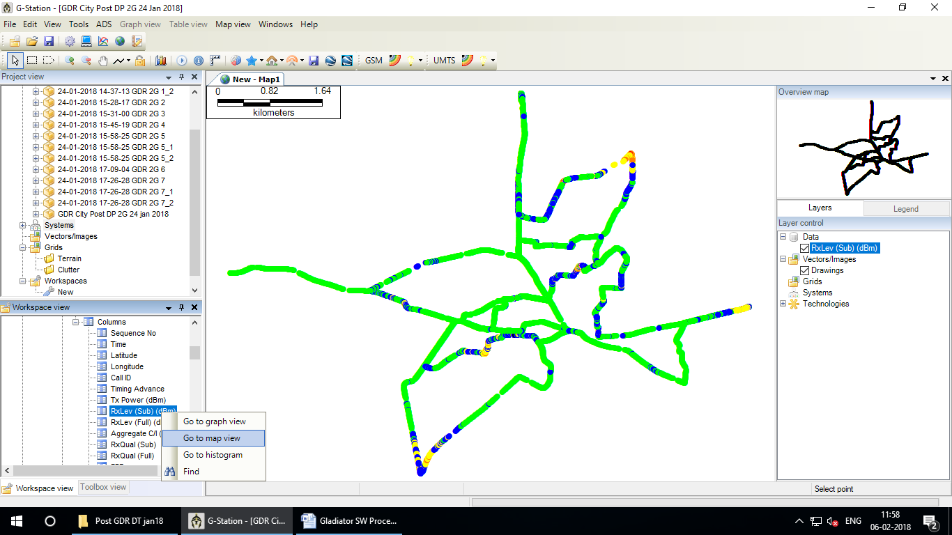

**Select RxLev (Sub) – Go to Map View**

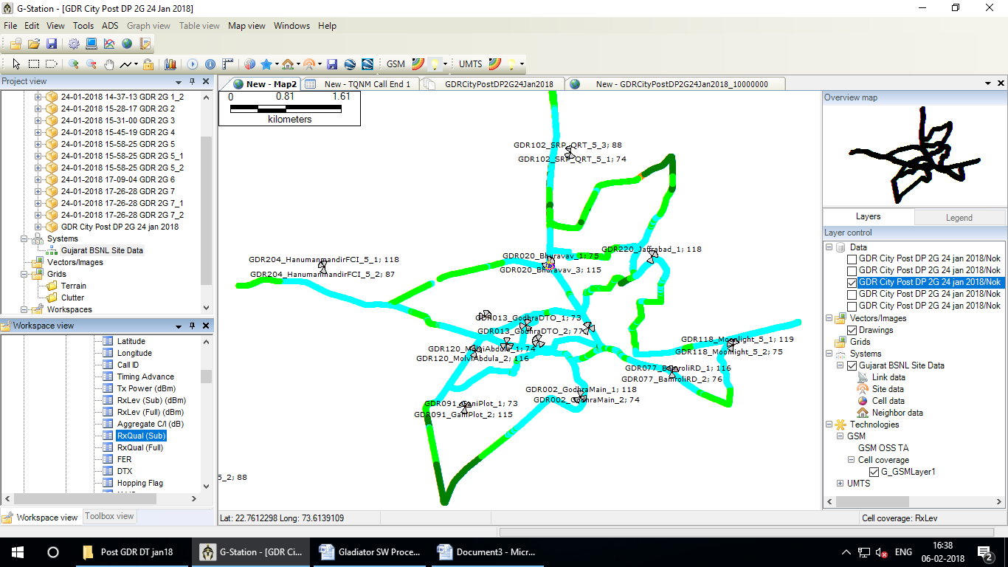

Select **RxQual(Sub)** - drag and drop to main screen

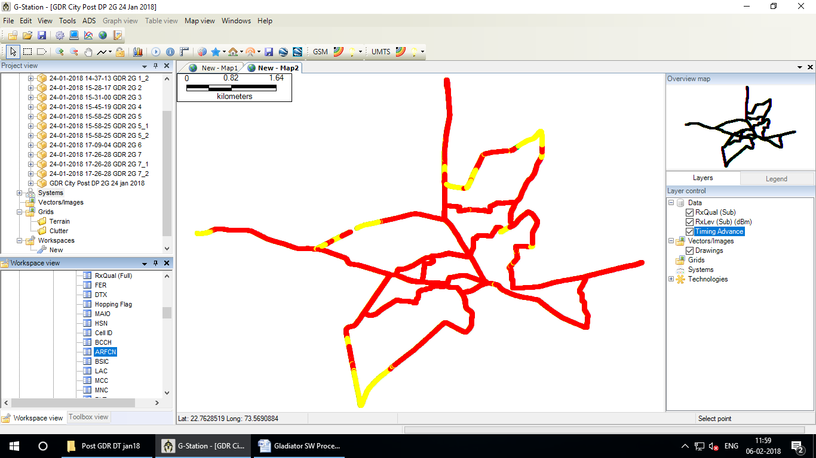

Select **ARFCN & Timing Advance one by one** - drag and drop to main screen

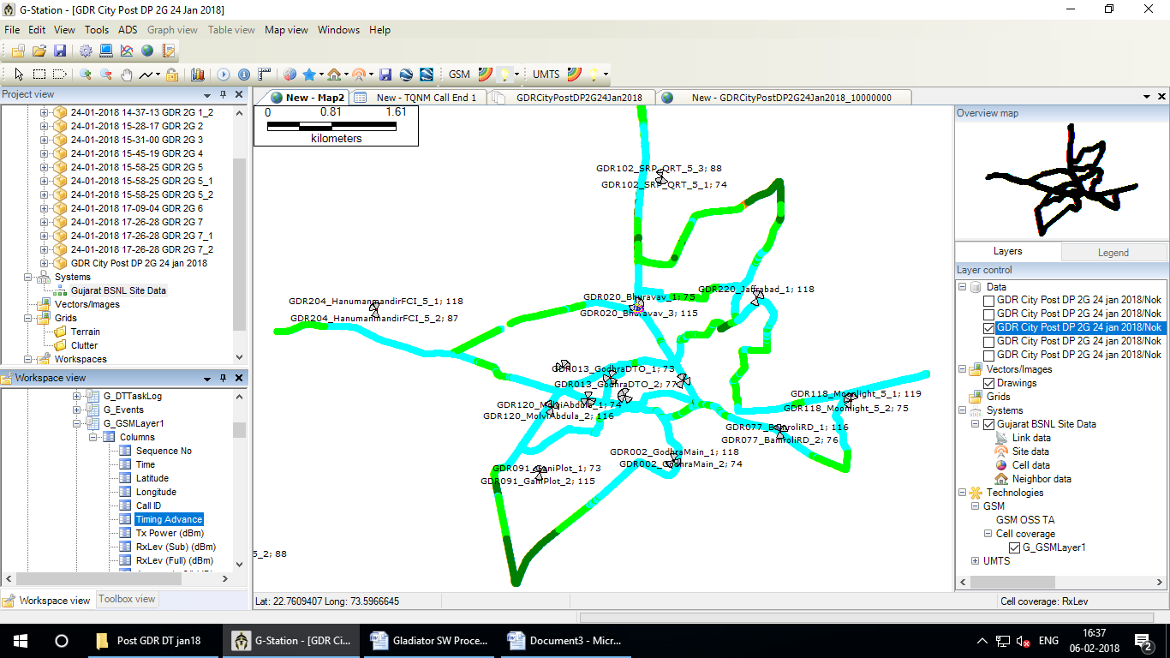

Select  **Timing Advance one by one** - drag and drop to main screen

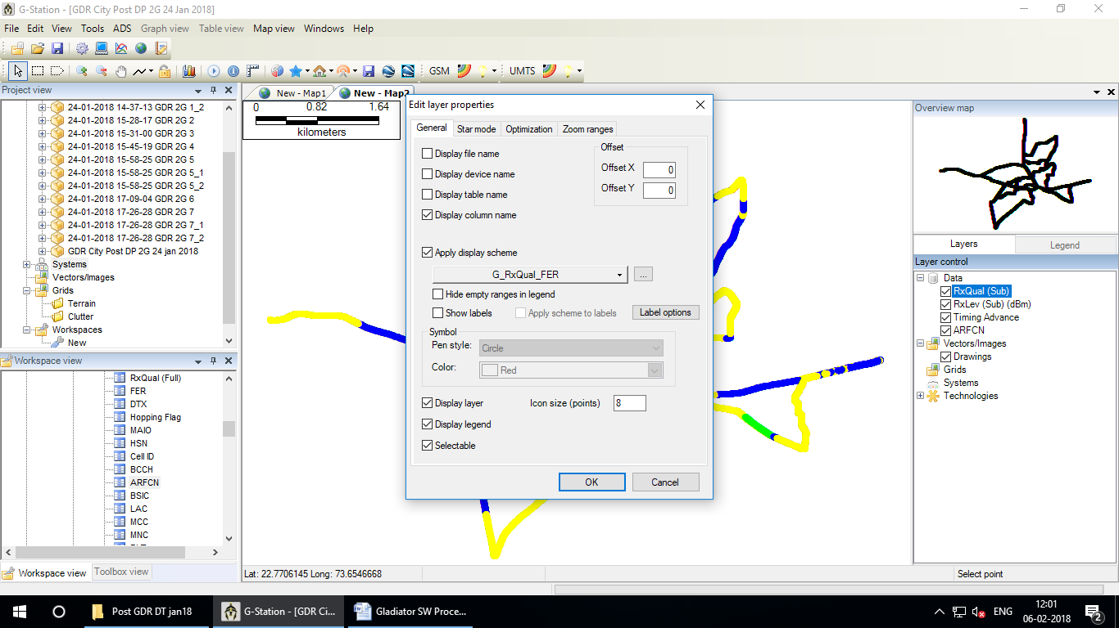

Double click on **RxQual (Sub)**

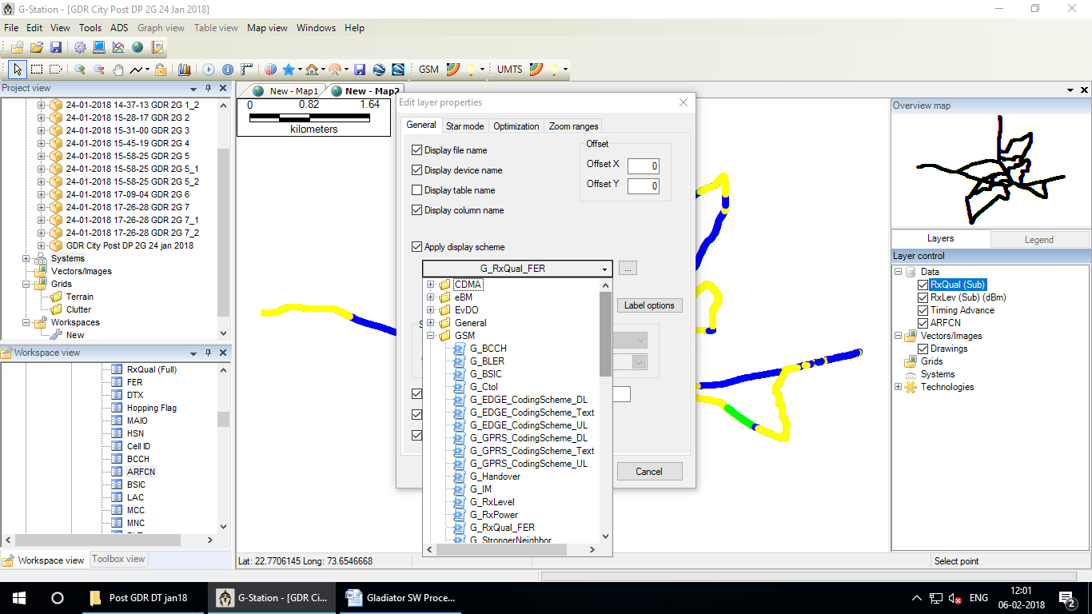

Tick on **Display file name** & **Display device name** & click on **G_RxQual_FER**

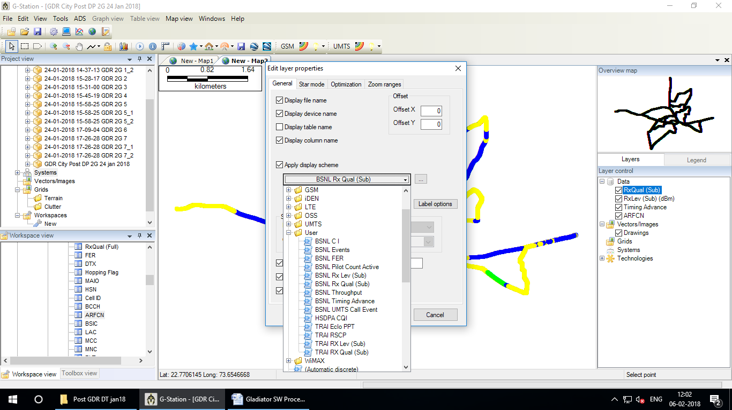

Change **G_RxQual_FER** to **BSNL Rx Qual (Sub) from User**

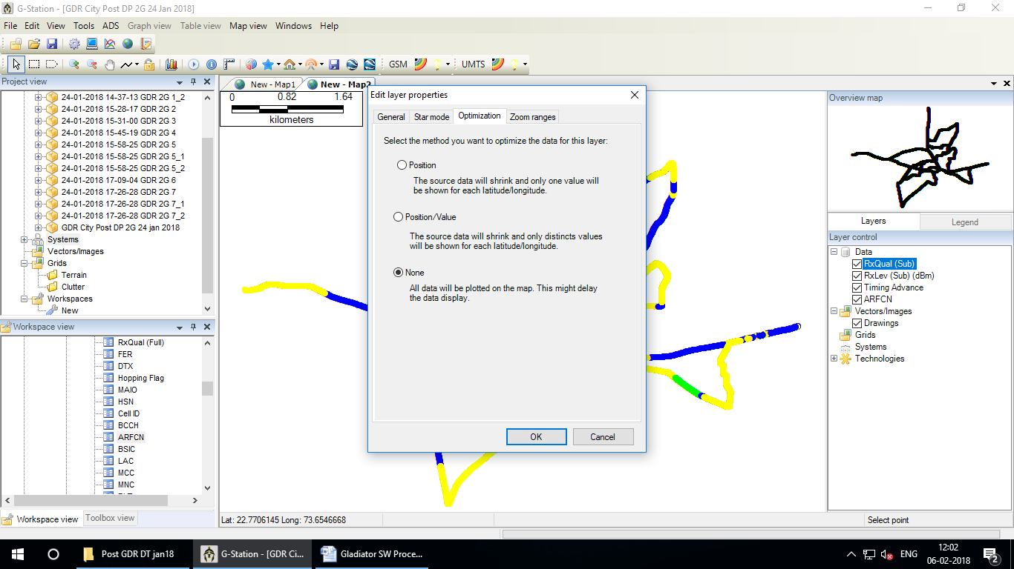

Select **None** - Ok

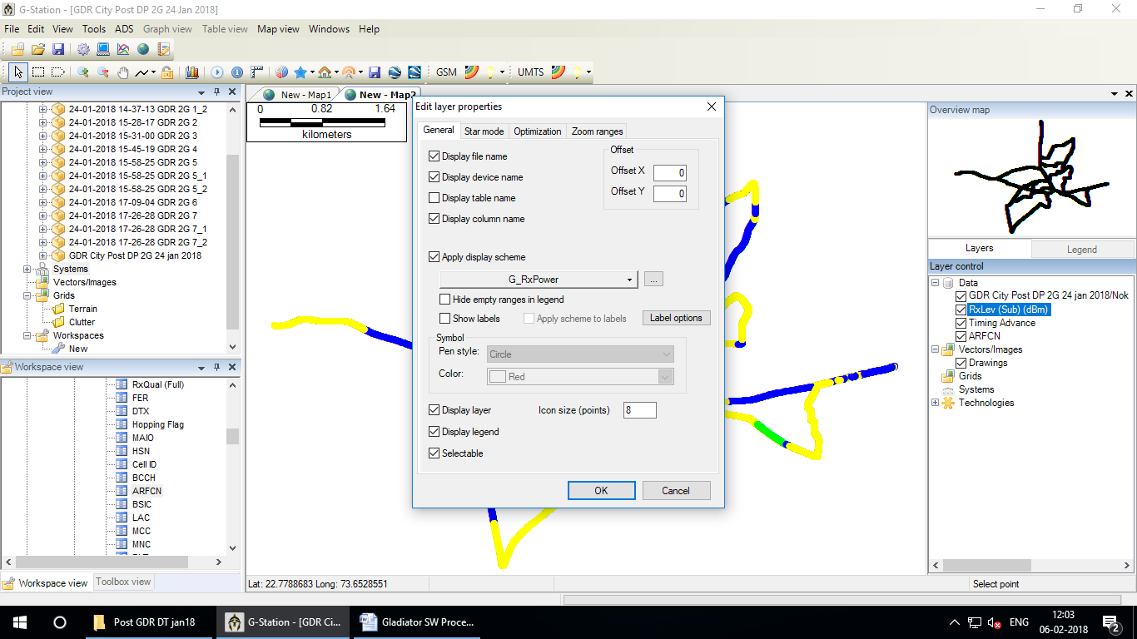

Double click on **RxLev (Sub)**

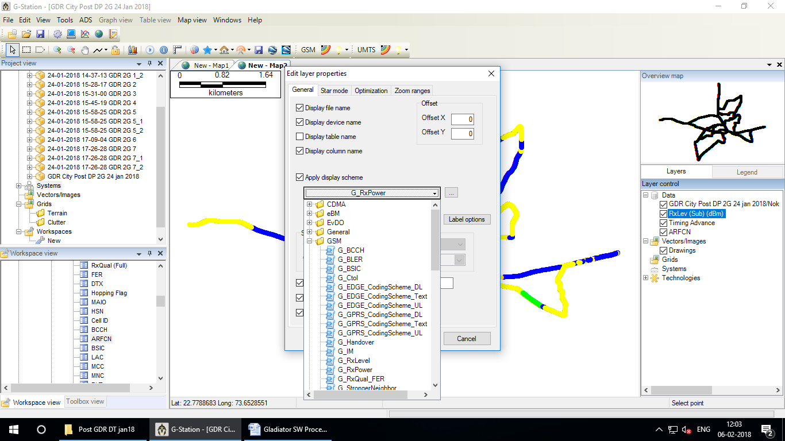

Tick on **Display file name** & **Display device name** & click on **G_RxPower**

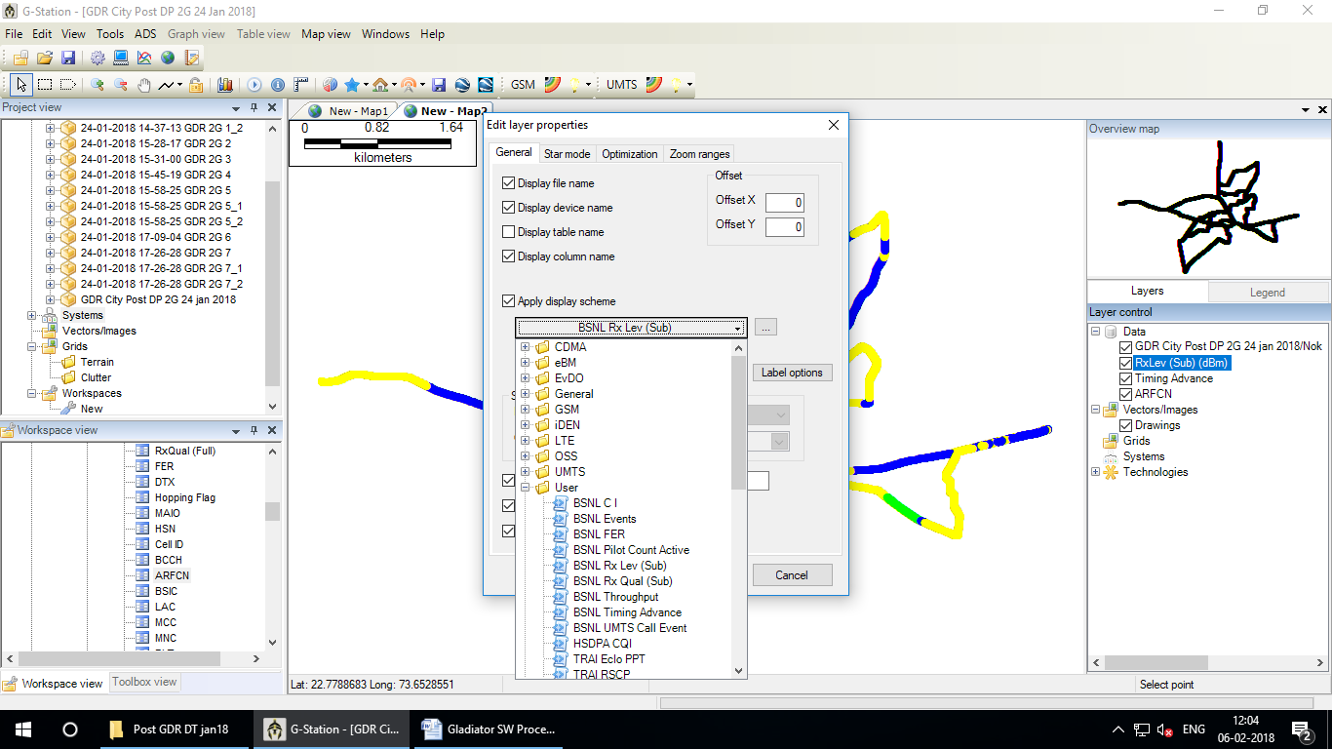

Change **G_RxPower** to **BSNL Rx Lev (Sub) from User**

s

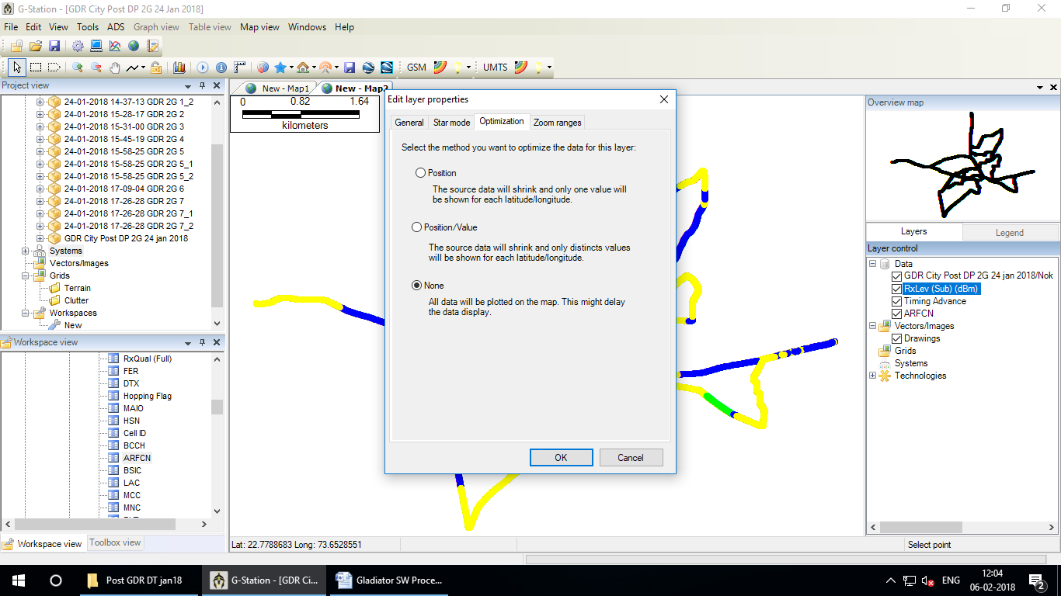

Select **None** - Ok

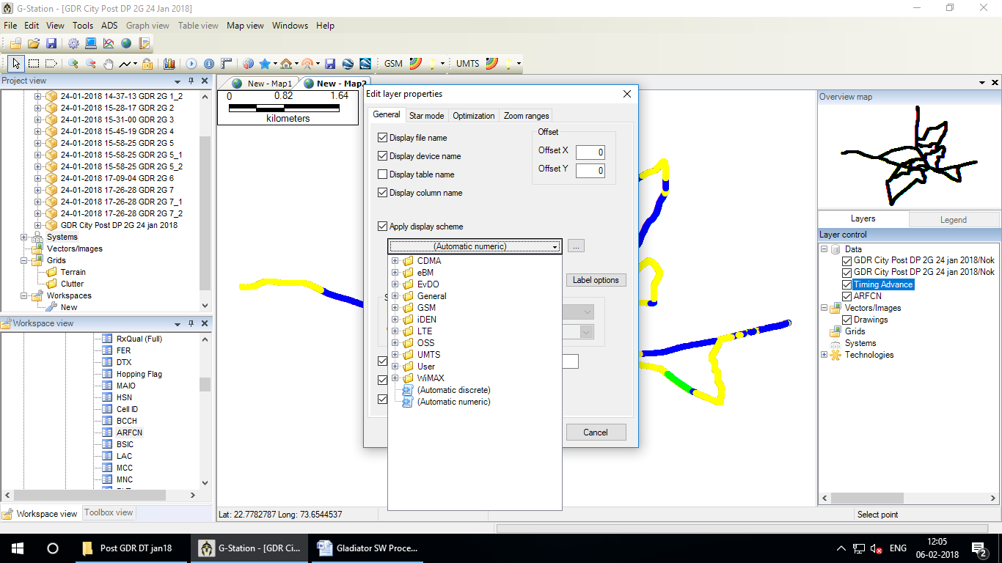

Double click on Timing Advance

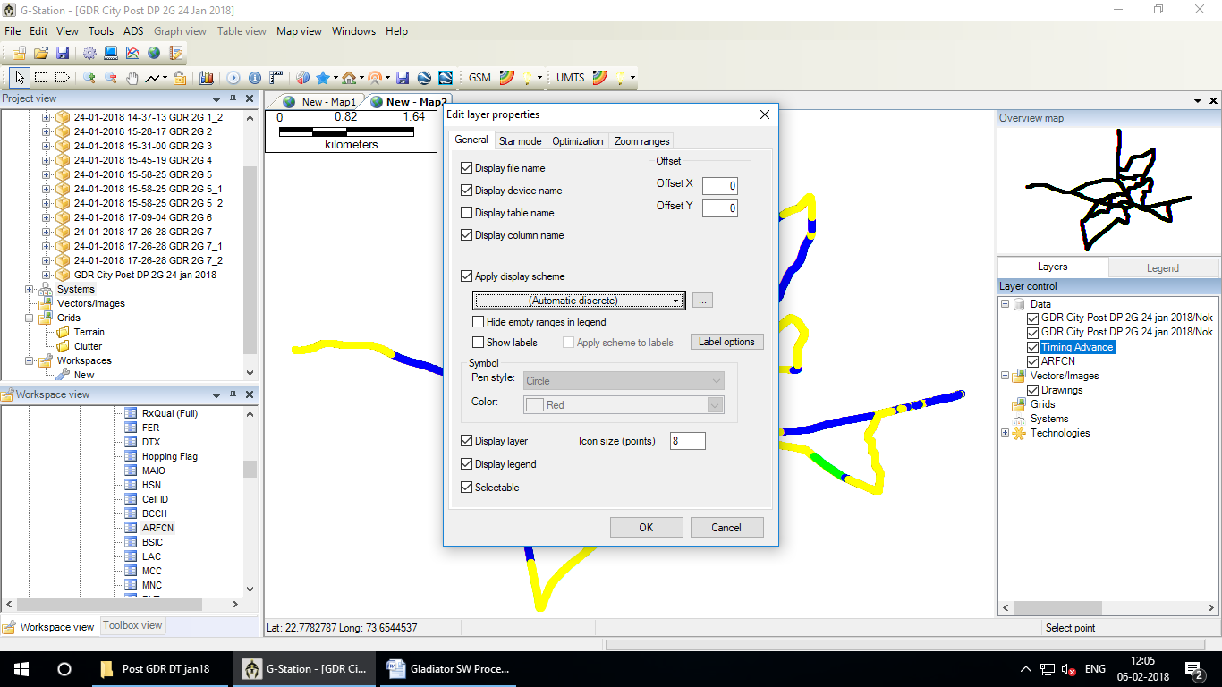

Tick on **Display file name** & **Display device name** & click on **(Automatic numeric)**

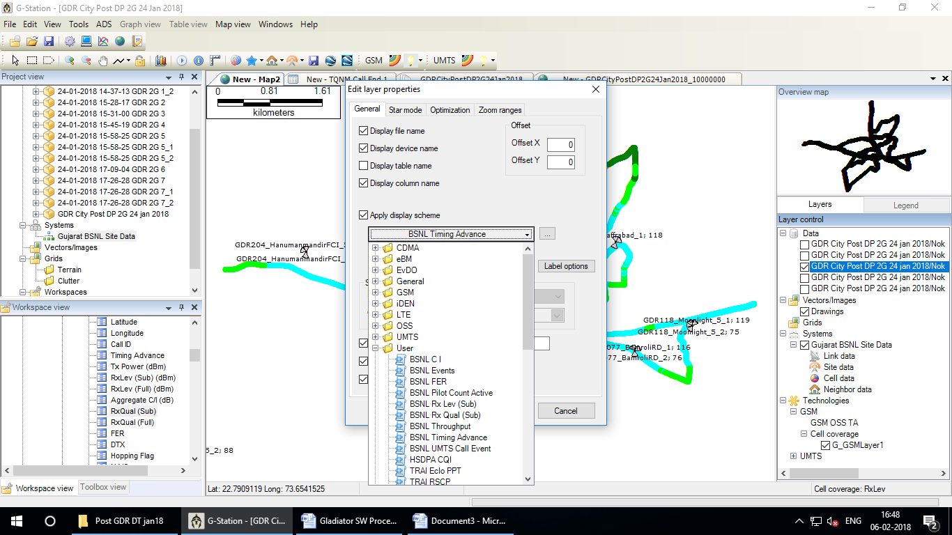

Change  **Automatic numeric to BSNL Timing Advance from Use**

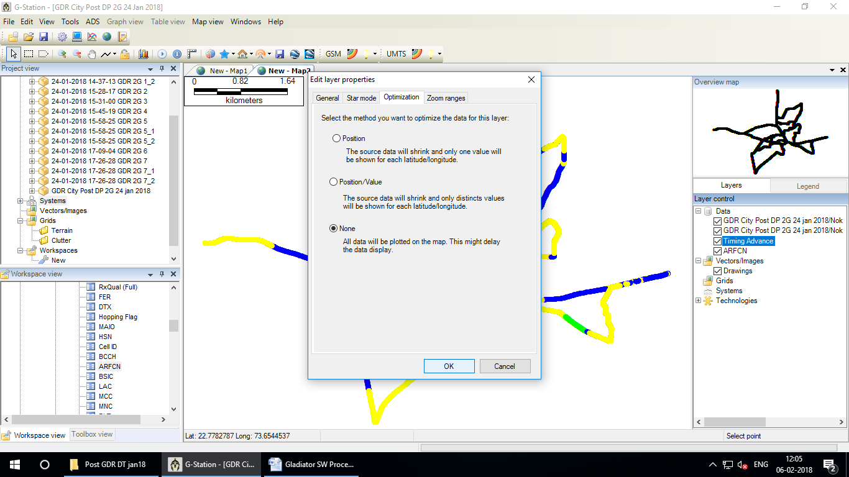

Select **None** - Ok

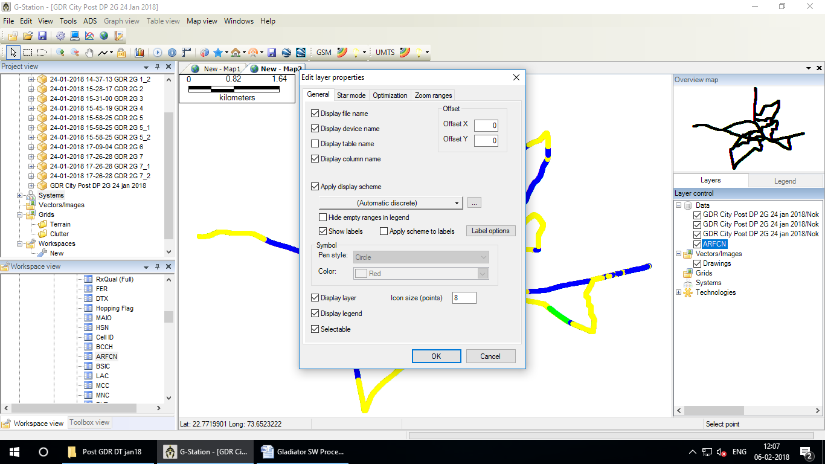

Double click on **ARFCN &** Tick on **Display file name** & **Display device name**

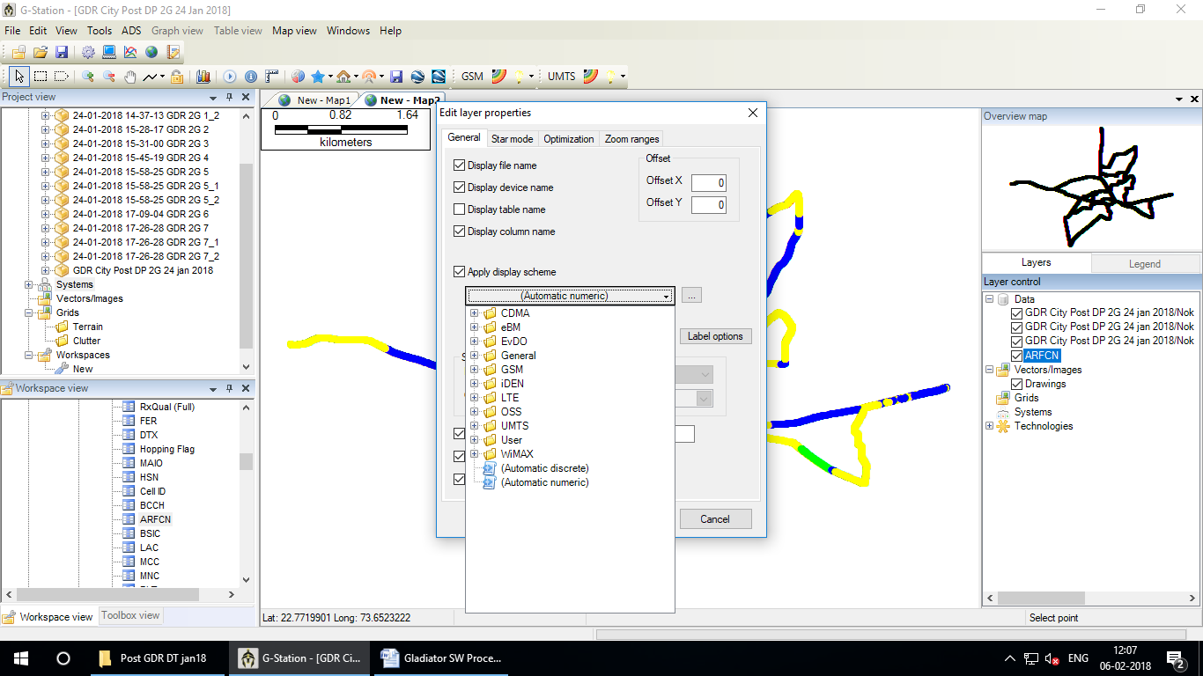

**Change Automatic numeric to Automatic Discrete**

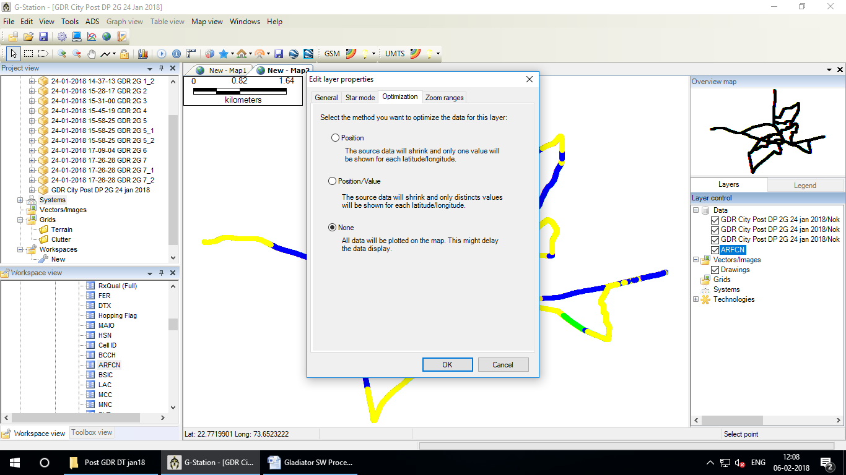

Select **None** - Ok

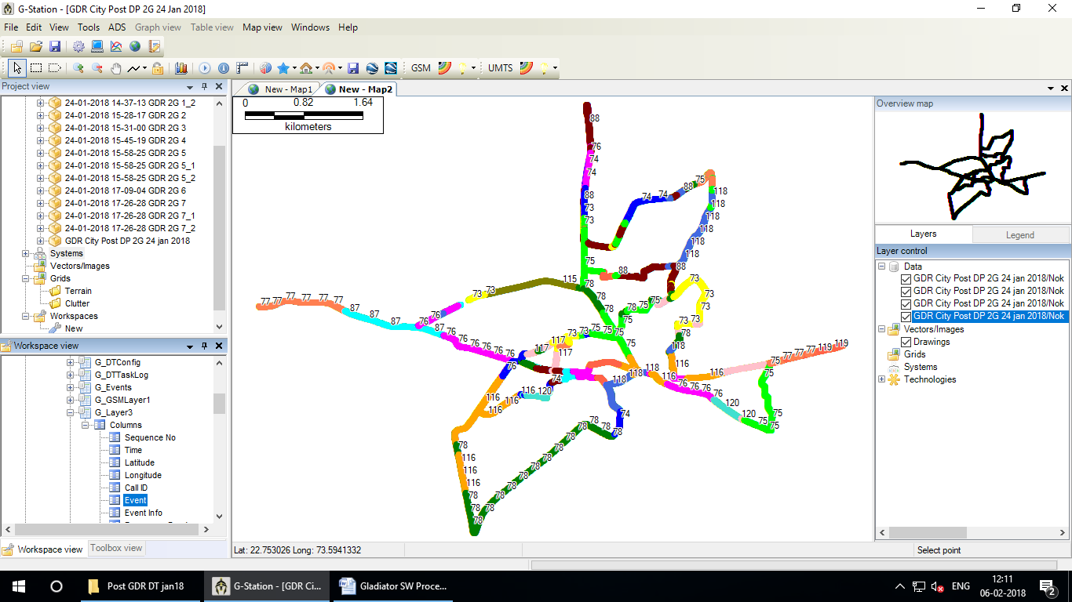

Expand G_Layer3 – Columns - Event

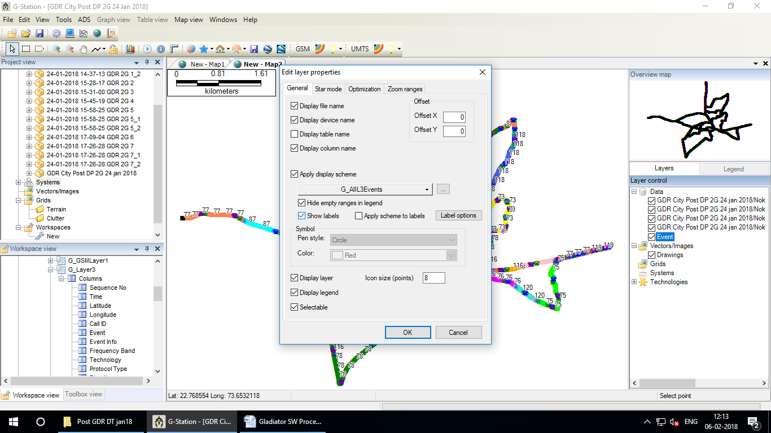

Double click on Event

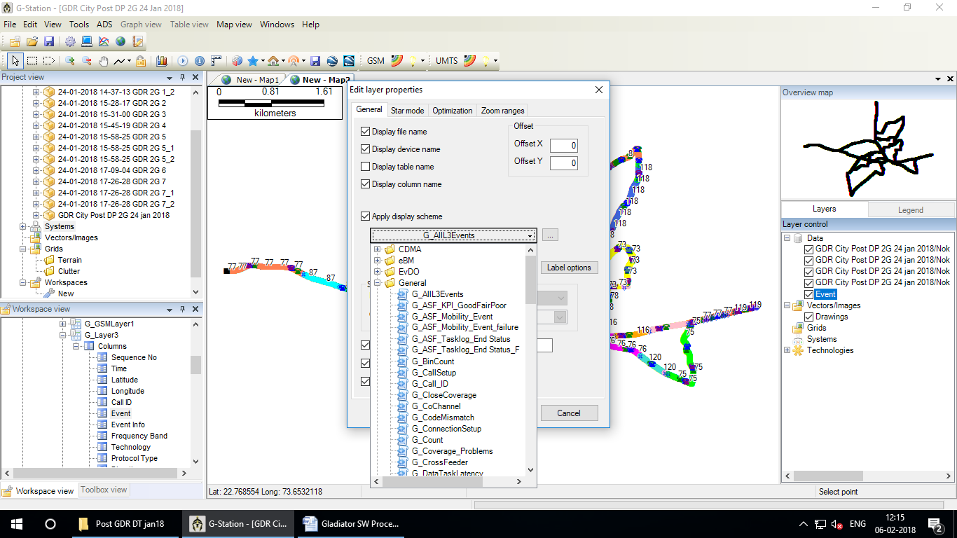

Tick on **Display file name**, **Display device name** & **Show label** & click on **G_AllL3Events** ( for all calls details)

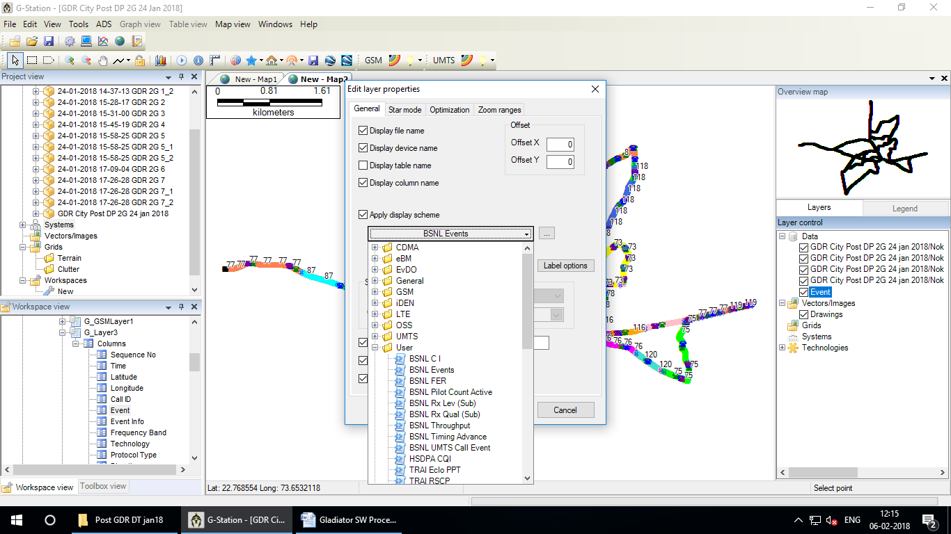

Change **G_AllL3Events to BSNL Events (for** handover failure details**)**

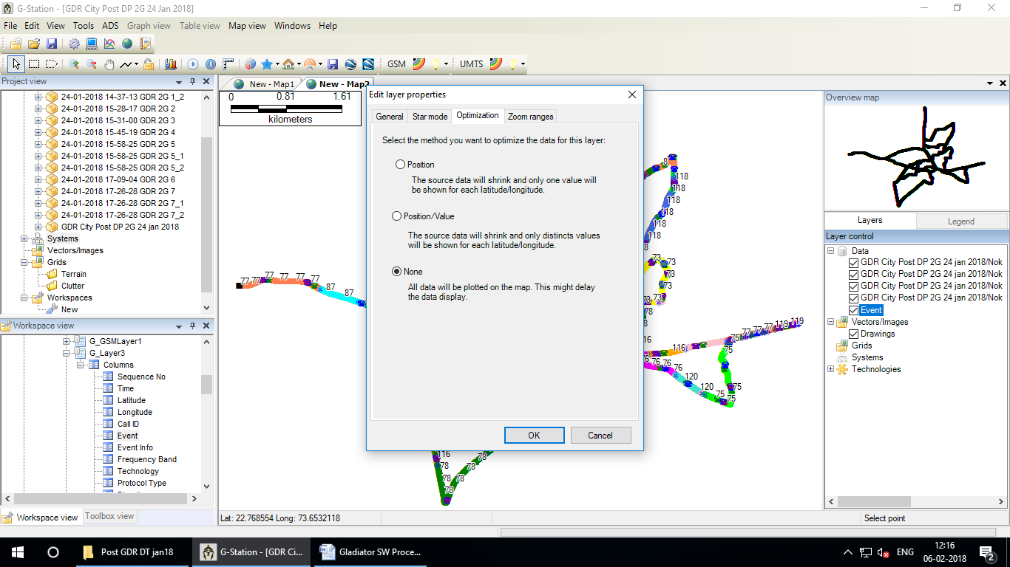

Select **None** – Ok

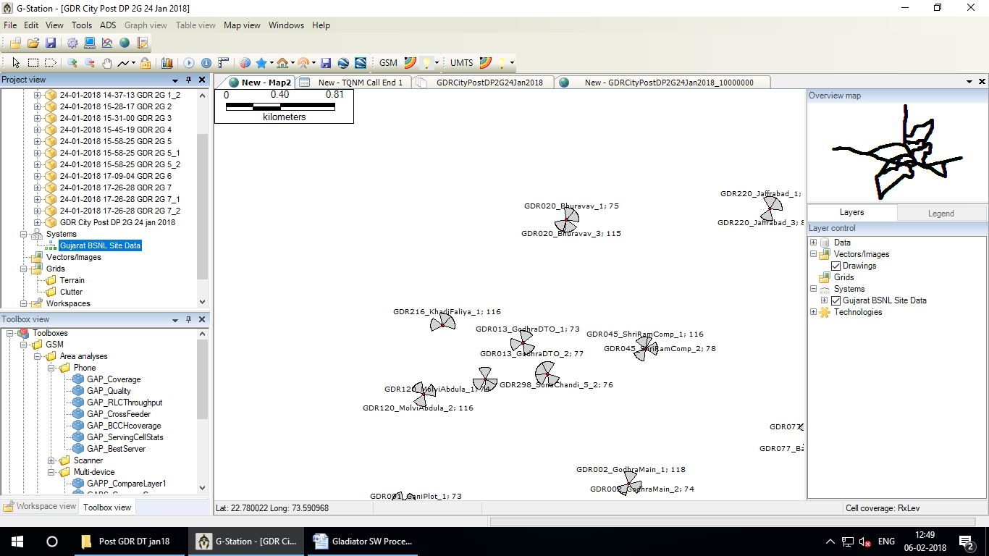

Select **Gujarat BSNL Site Data** and drag and drop to main screen

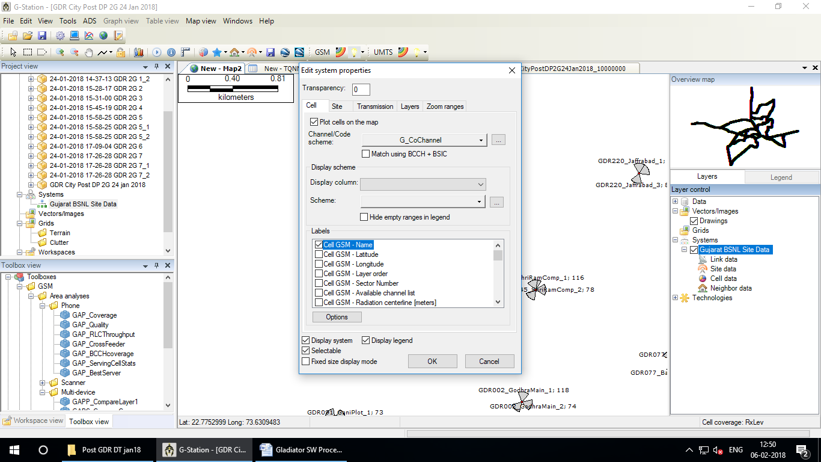

Double Click on **Gujarat BSNL Site Data** and Tick **Cell GSM - Name**

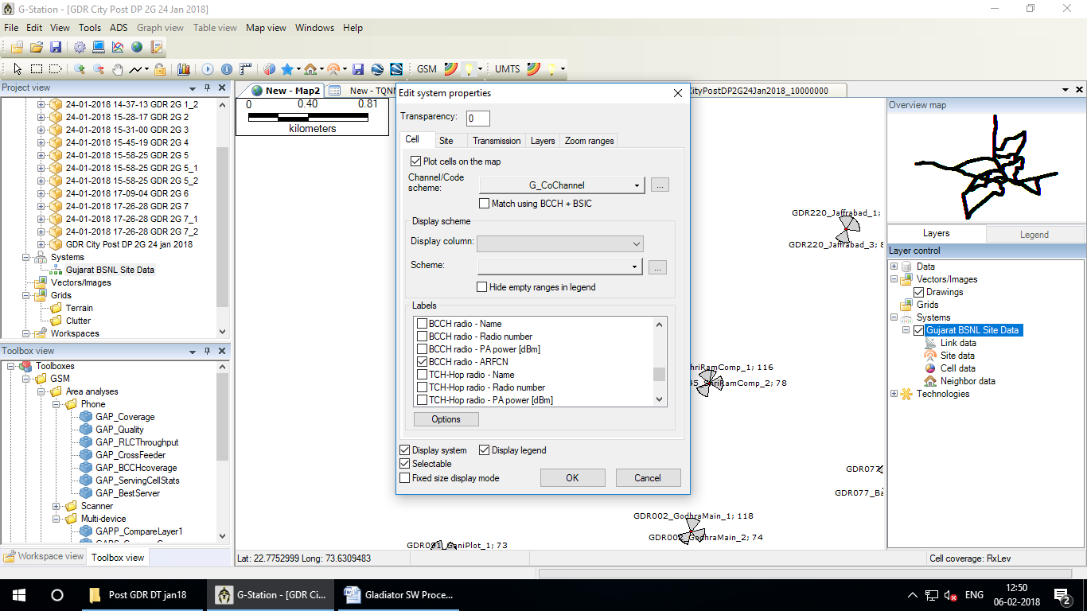

Tick BCCH radio – **ARFCN** - **OK**

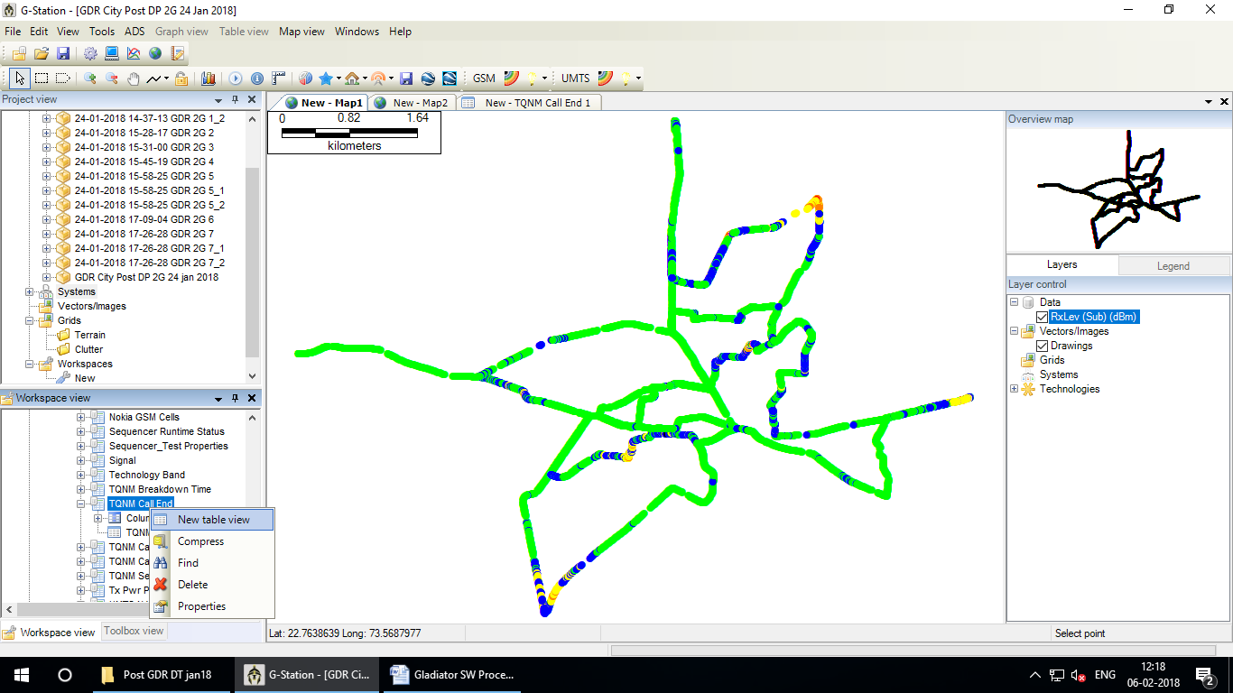

Go to Workspace view - Select **TQMN call End**  – Right click -**New table view**

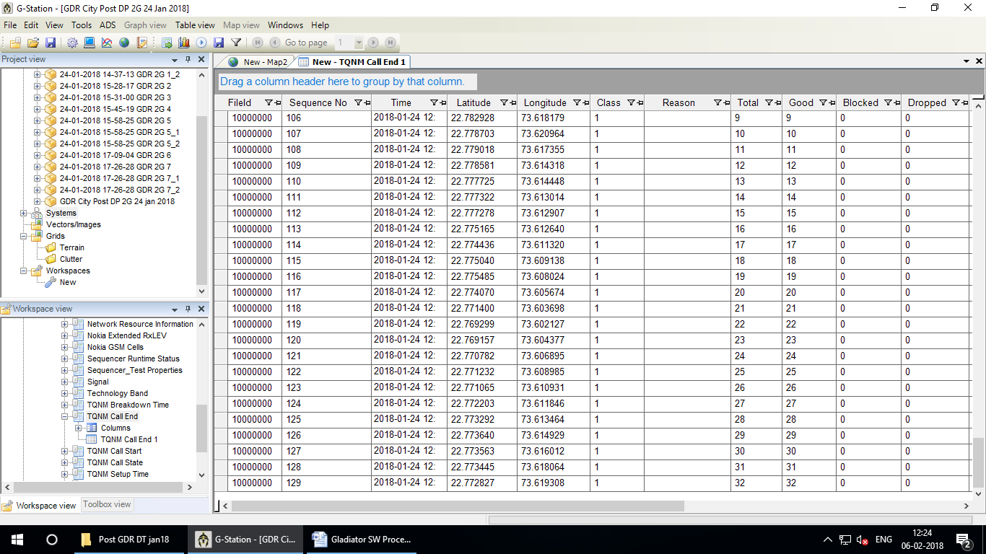

Calculate total Call, Blocked & Drop

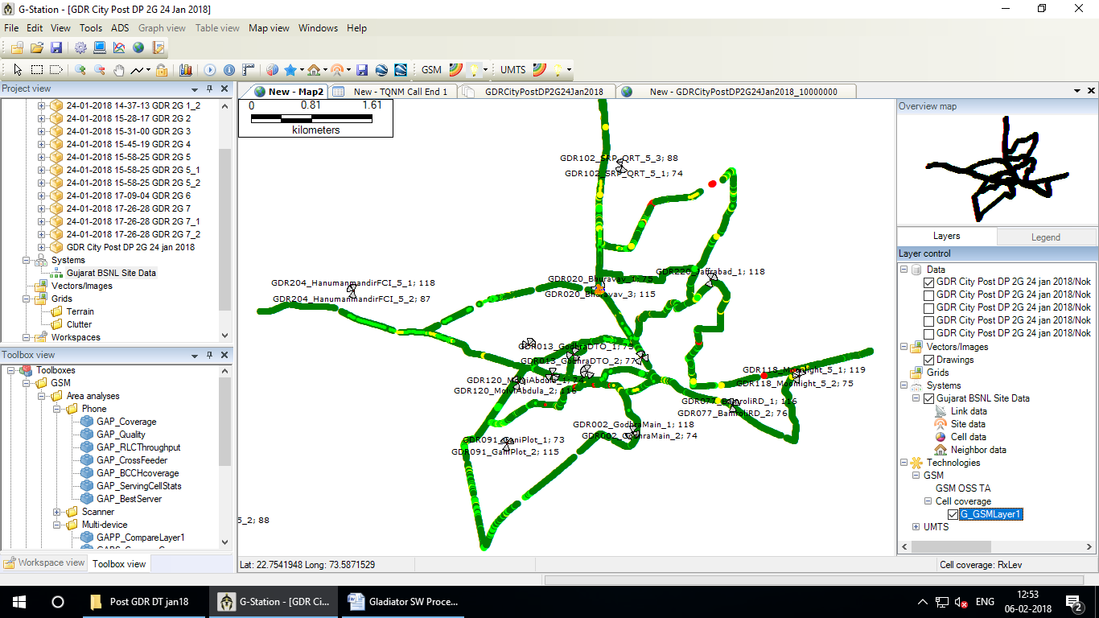

Select GSM-Cell coverage – **G_GSMLayer1**

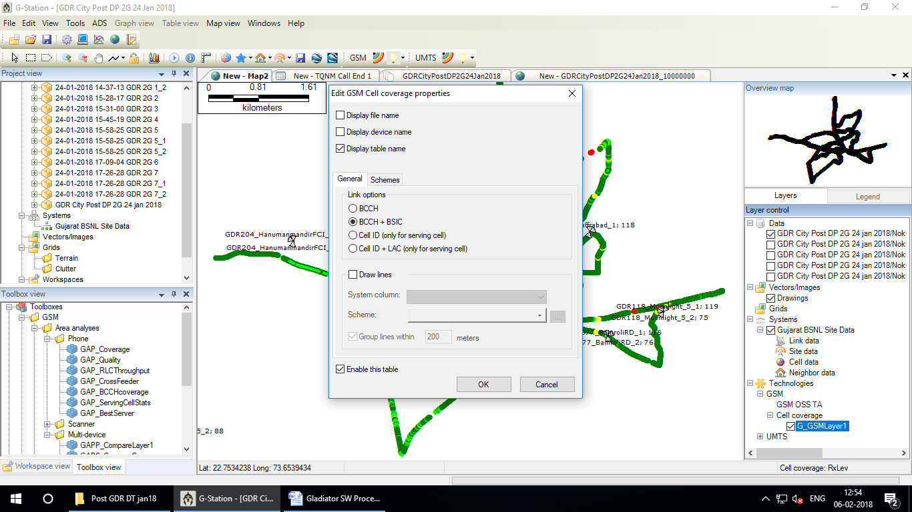

Double Click on **G_GSMLayer1** & in General Select **BCCH + BSIC - OK**

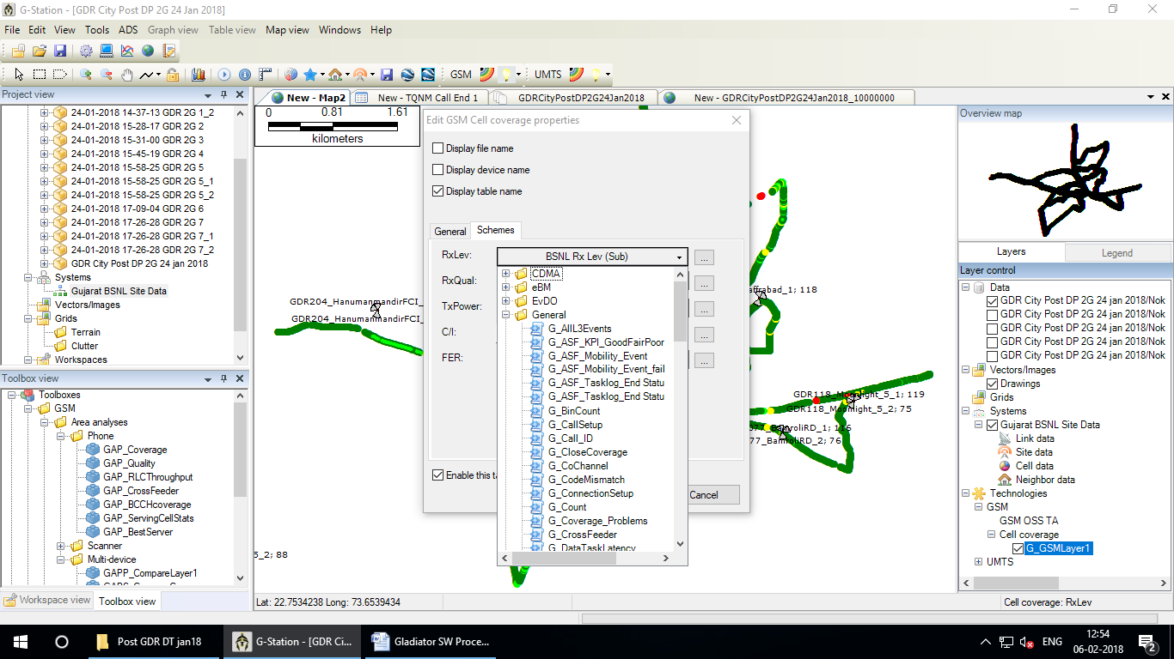

Click on Schemes then Click on RxLev

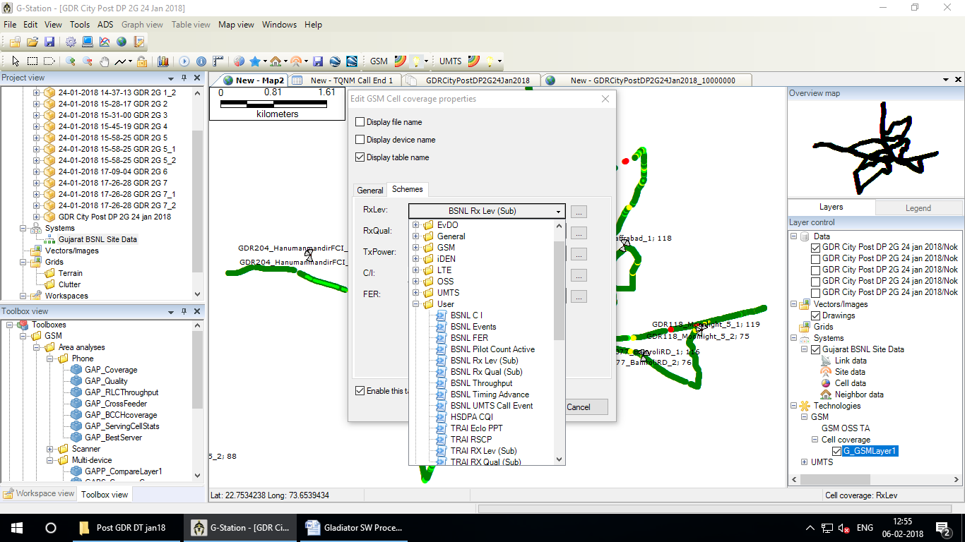

Select **BSNL Rx Lev(Sub)** from user

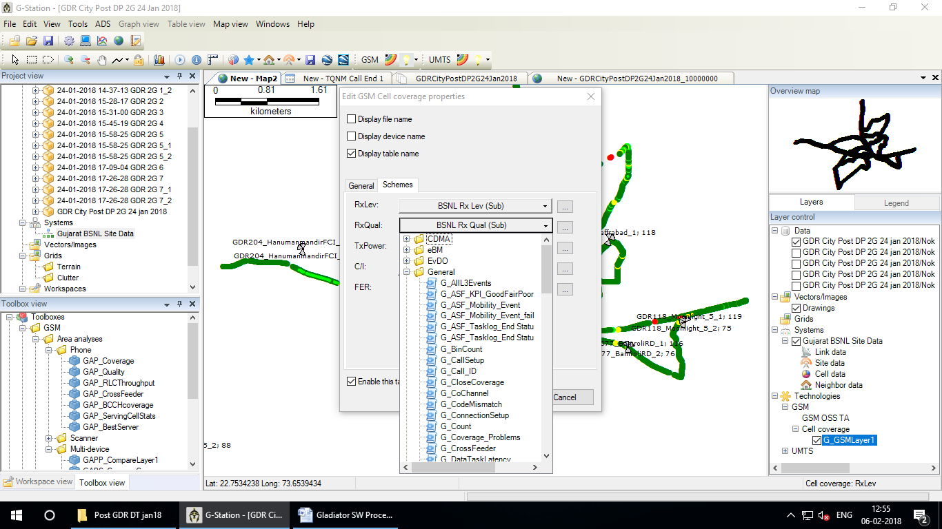

Click on RxQual

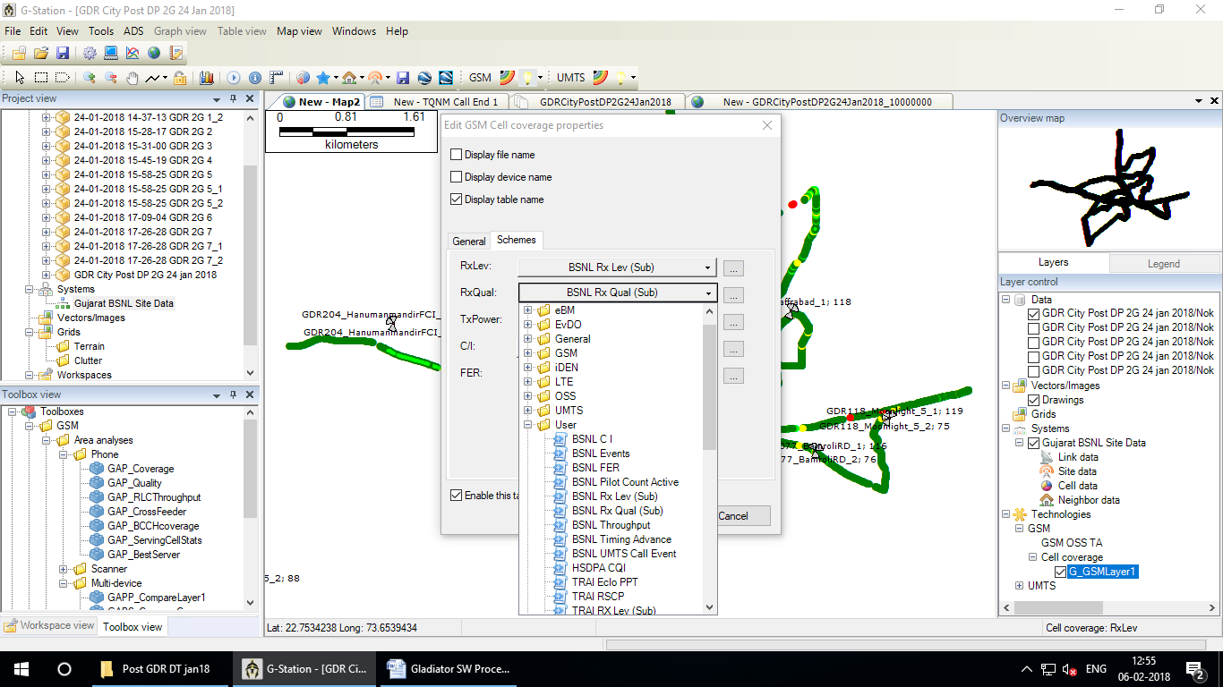

Select **BSNL Rx Qual(Sub)** from user

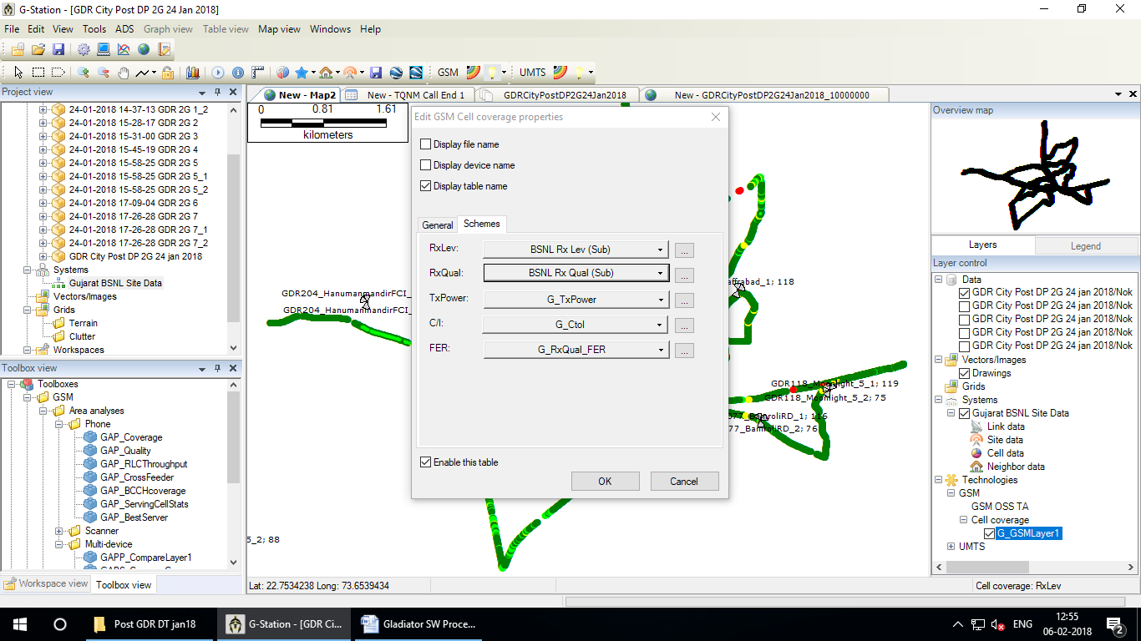

**Than OK**

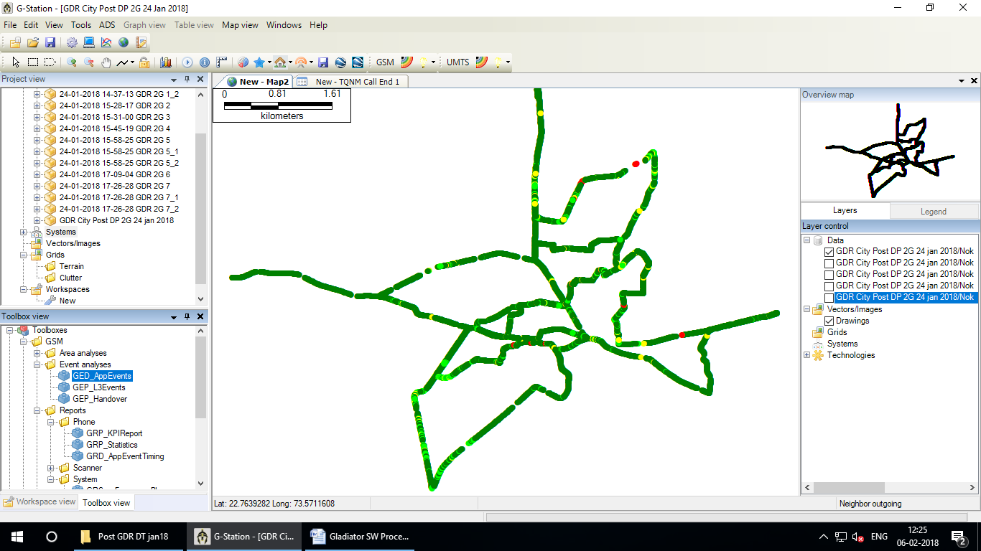

Go to **ToolBox view** – select **GED_AppEvents**

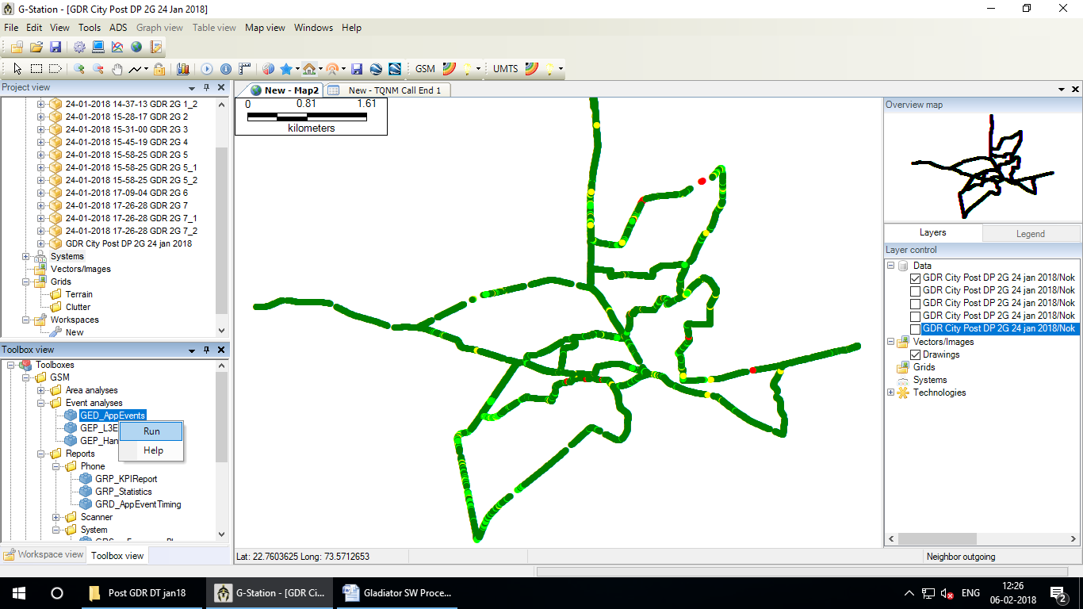

Right Click – click Run

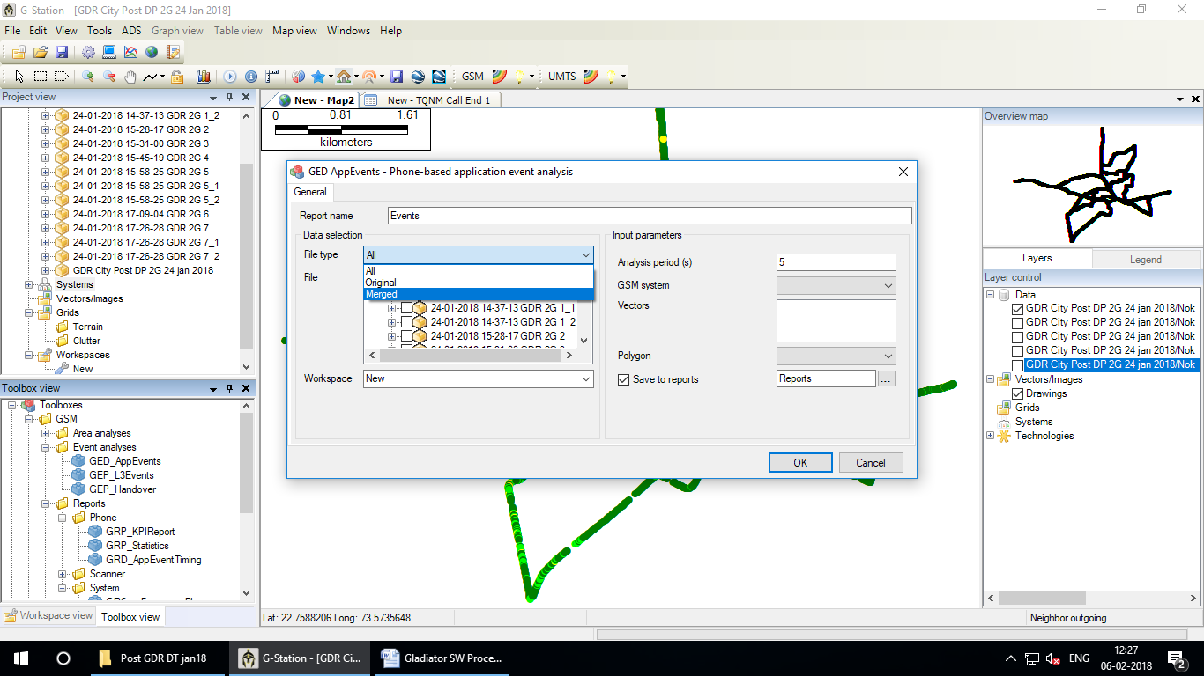

Select **File Type - Merged**

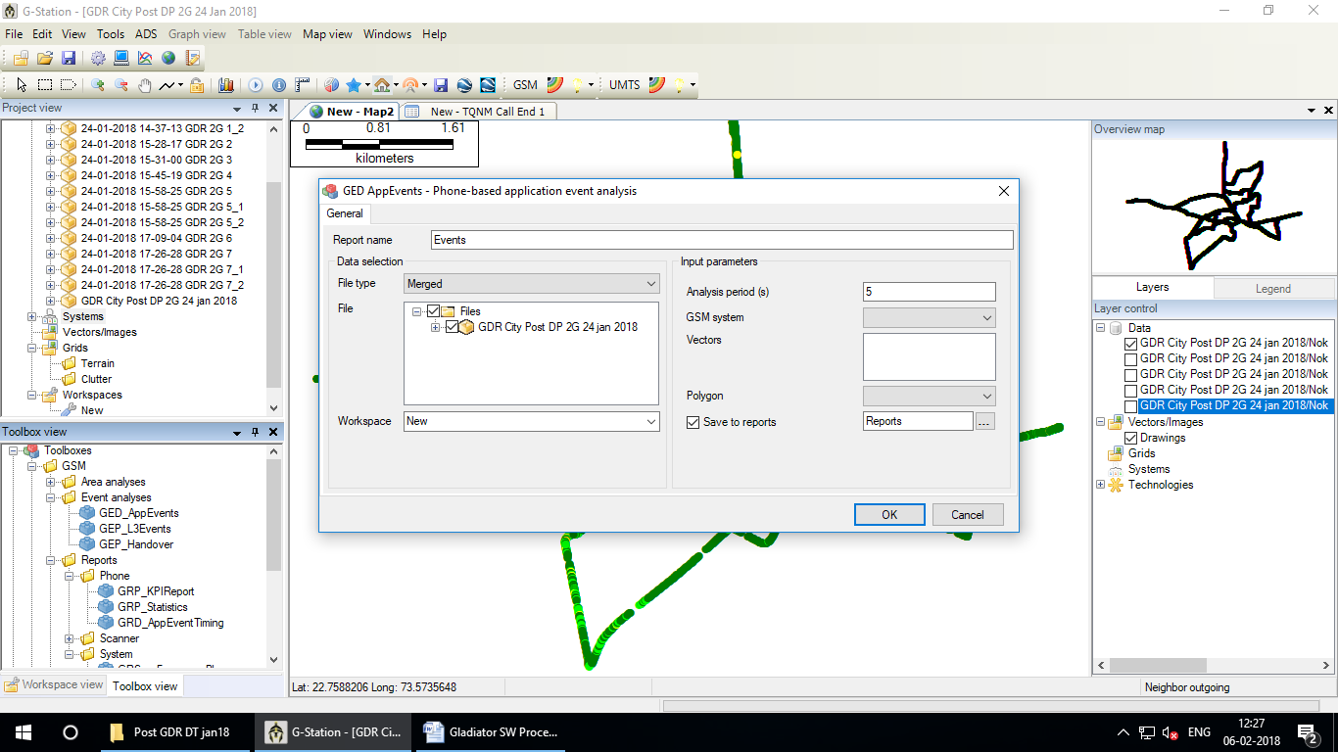

Select **File**

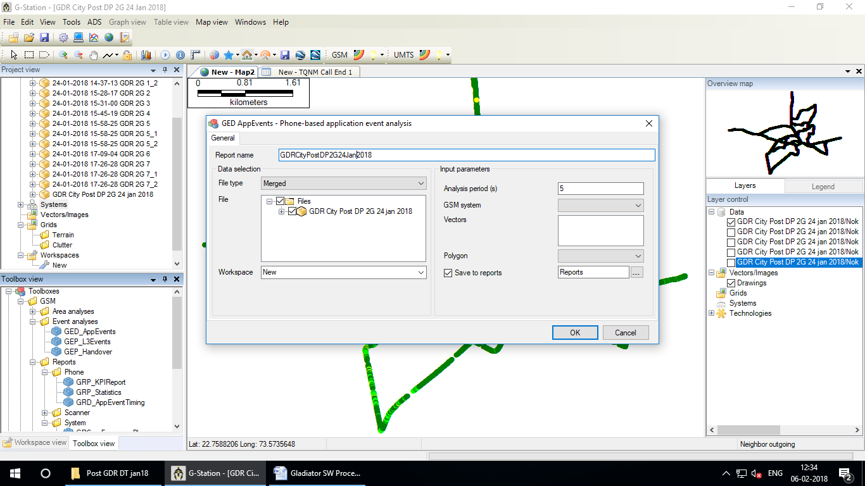

Give **Report name** without space

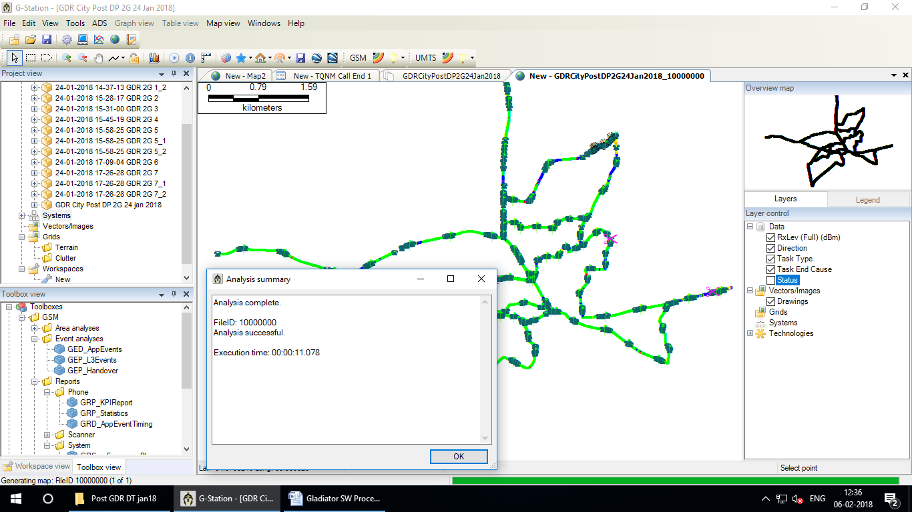

Its shows success calls , Blocked calls & no Communication in **Legend**

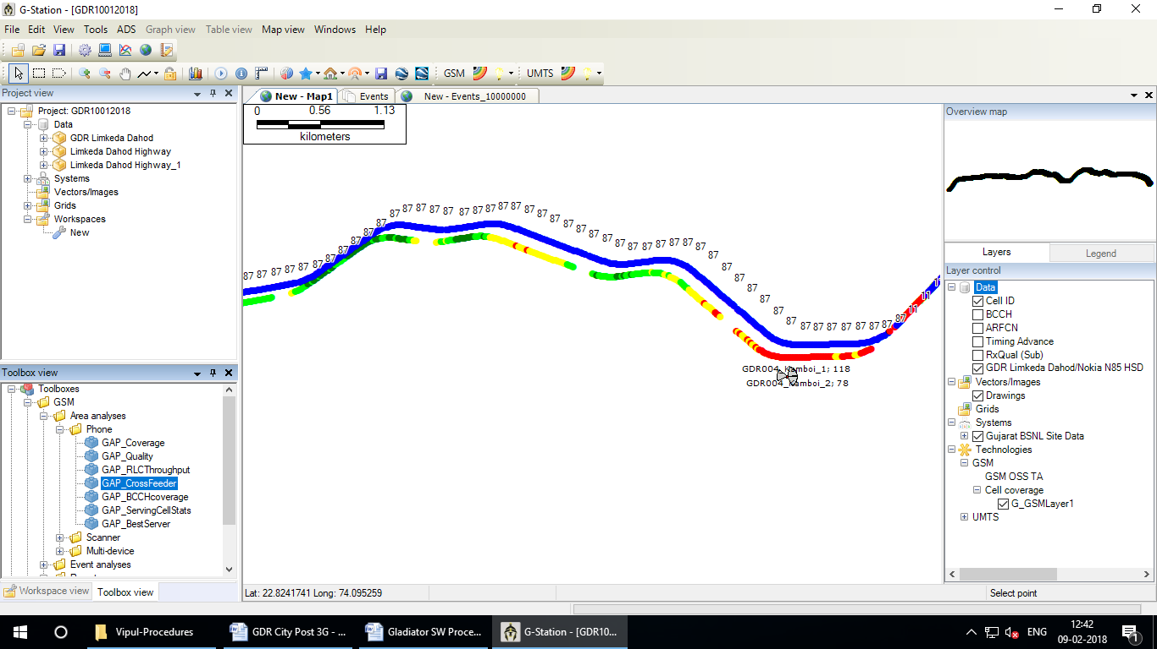

Go to Toolboxes – GSM – Area analyses – Phone – GAP_CrossFeeder

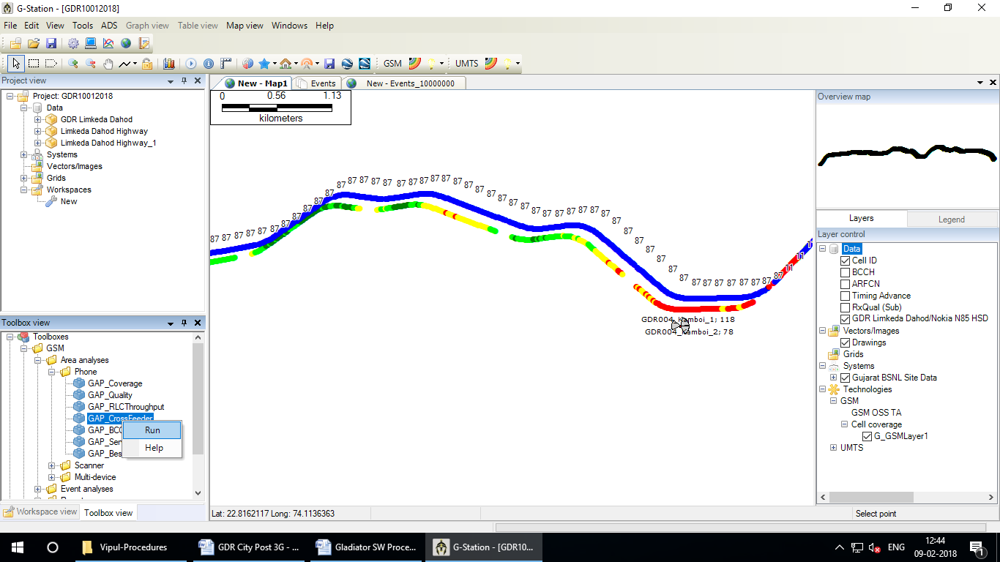

Right Click on GAP_CrossFeeder – Run

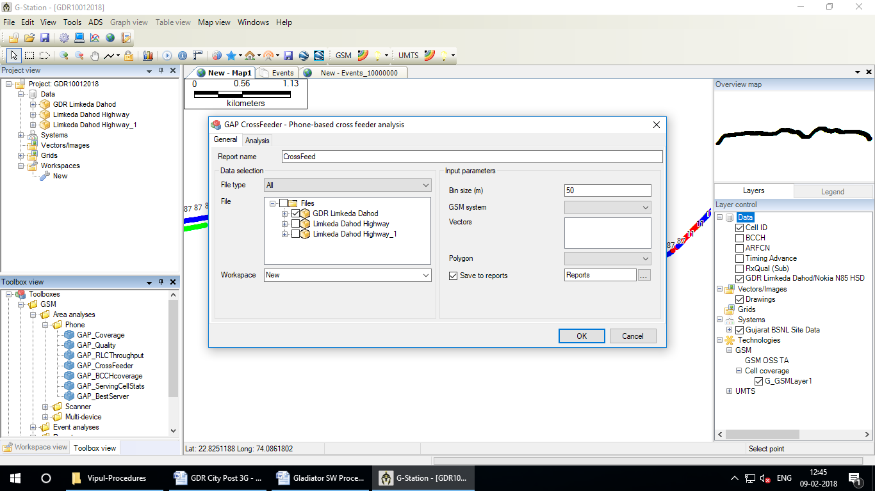

Select File and Click on file type

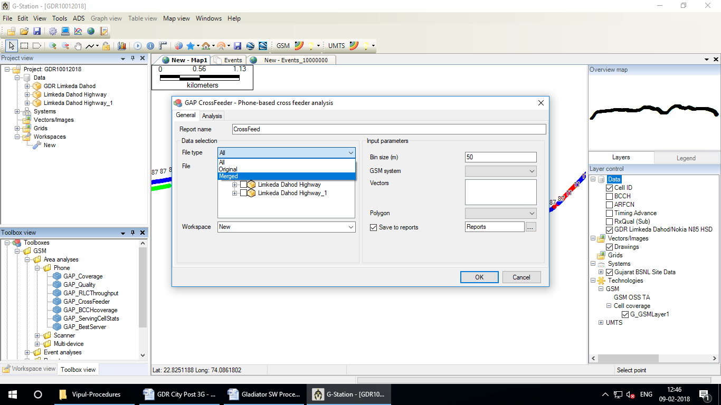

Select on Merged

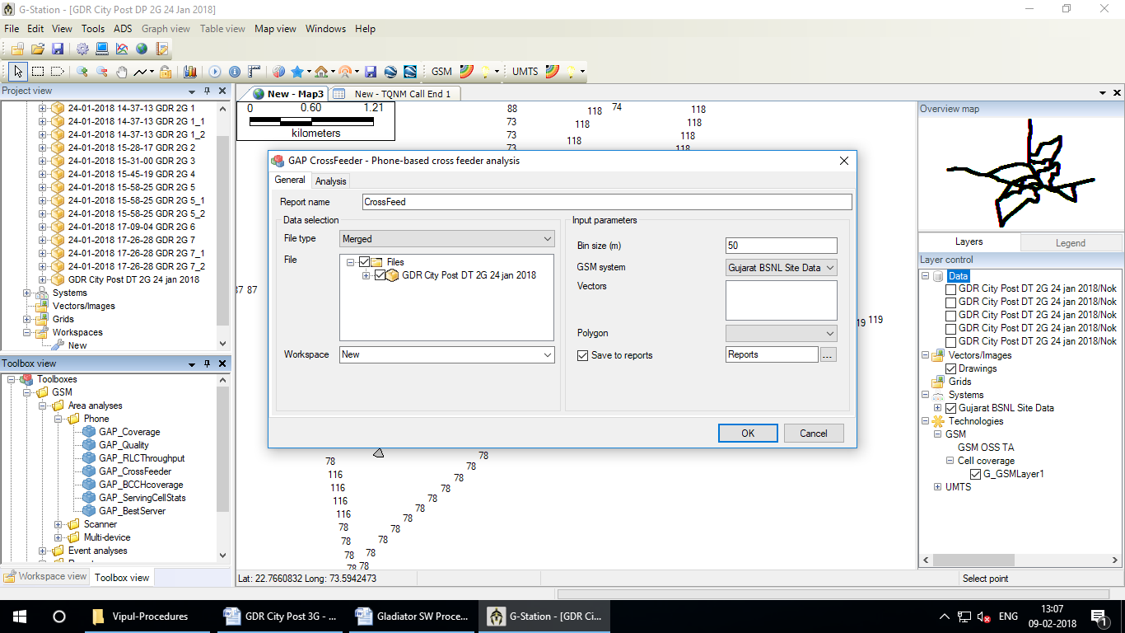

Select GSM system than Click on OK

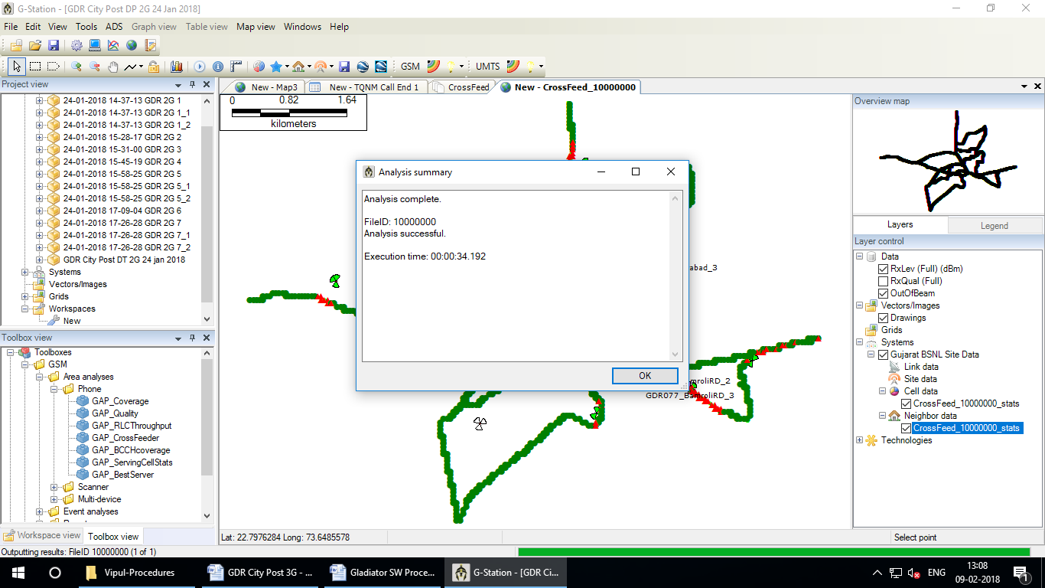

Click on OK

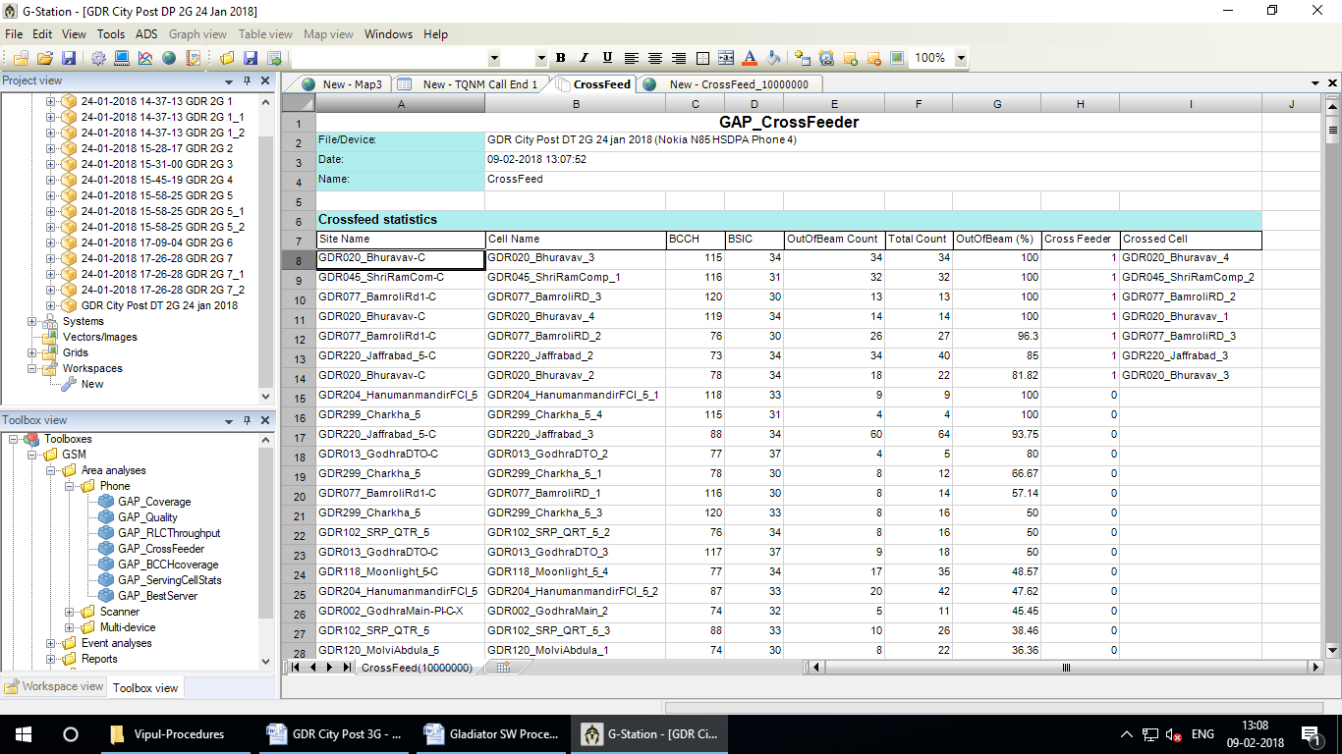

This sheet shows possibility of swapping between sectors